Interplay of inversion-less and inversion-based terahertz stimulated intracenter emission

in isotopically enriched silicon doped by bismuth

S.G. Pavlov ¹⁾, N.V. Abrosimov ²⁾, N. Deßmann ³⁾, U. Böttger ¹⁾, B. Redlich ⁴⁾, A.F.G. van der Meer ⁴⁾, R.Kh. Zhukavin ⁵⁾, V.N. Shastin ⁵⁾, K. Irmscher ²⁾, H. Riemann ²⁾ and H.-W. Hübers ^{1,3)}

¹⁾ Institute of Planetary Research, German Aerospace Center, Berlin, Germany

²⁾ Leibniz Institute of Crystal Growth, Berlin, Germany

³⁾ Institut für Optik und Atomäre Physik, Technische Universität Berlin, Berlin, Germany

⁴⁾ FELIX Facility, Radboud University, Nijmegen, The Netherlands

⁵⁾ Institute for Physics of Semiconductors, Nizhny Novgorod, Russia

Two types of terahertz-range stimulated emission involving intracenter transitions of bismuth atoms in isotopically enriched silicon has been realized under optical excitation by mid-infrared free electron laser (FELIX Facility, Radboud, the Netherlands) at cryogenic temperatures, ~ 5 K. In comparison with the similar stimulated emission observed for natural silicon crystals [1], strong interplay between Raman laser emission and inverted intracenter lasing has been observed (Fig. 1). This competition is caused by interaction of particular donor levels those populations play a critical role in forming inverted electron distributions required for intracenter laser action (for instance 2p± →1s(E) bismuth transition in Fig. 1) versus dominant population of the ground impurity state (inversion-less), 1s(A₁), what is required for Raman Stokes lasing.

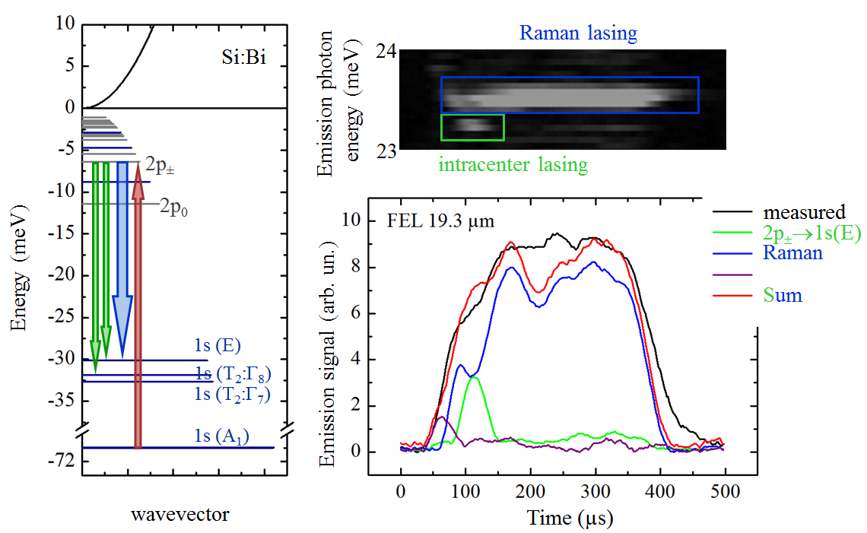

Fig. 1. Left: ²⁸Si:Bi lasing scheme showing pump (arrow upwards) and emission transitions (arrows downwards). Right: Dynamics of the laser emission pulses (lower) and frequency (upper) during the FEL pump pulse.

Authors acknowledge the support through the EU initiative “CALIPSO” (Project # FELIX-2013-2-2) and the Russian Foundation for Basic Research (grants # 14-02-00638, 13-02-97116-povolzhie).

References

- S. G. Pavlov, U. Böttger, R. Eichholz, N. V. Abrosimov, H. Riemann, V. N. Shastin, B. Redlich, and H.-W. Hübers. Terahertz lasing from silicon by infrared Raman scattering on bismuth centers. // Appl. Phys. Lett. 95, 2009 р. 201110.

