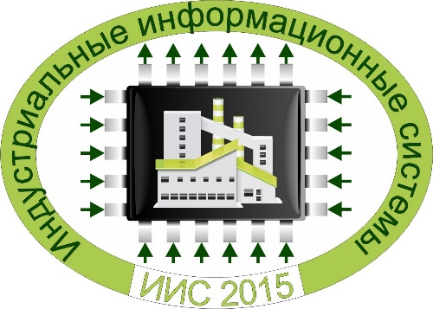

**All-Russian Conference**

**with international participation   
«Industrial Information Systems» – IIS-2015**

***Novosibirsk, Akademgorodok,***

***20-24 September, 2015***

**Topics**

* Industrial information systems: mathematical support, software and hardware.
* Industrial control systems.
* Information monitoring systems.

**Organizers**    
Design and Technology Institute of Digital Techniques, SB RAS

Institute of Computational Technologies, SB RAS

Institute of Automation and Electrometry, SB RAS

Institute of Computational Modelling, SB RAS

Institute for System Dynamics and Control Theory, SB RAS

Special Design and Technological Bureau «Nauka», Krasnoyarsk Scientific Centre, SB RAS

Novosibirsk State University

Novosibirsk State Technical University

Siberian State University of Telecommunications and Information Sciences

**Conference Committee**

**Academician Yu.I.Shokin**, ICT SB RAS, Novosibirsk - **Chairman**

**Dr. S.K. Golushko**, DTI DT SB RAS, Novosibirsk – **Vice-Chairman**

**Academician V.I.Bychkov,** ISD CT SB RAS, Irkutsk,

**Corr.Mem. of RAS V.V.Shaidurov,** ICM SB RAS, Krasnoyarsk,

**Corr.Mem. of RAS A.M.Fedotov,** ICT SB RAS, Novosibirsk,

**Dr. A.V.Vostretsov,** NSTU, Novosibirsk

**Dr. Yu.N.Zolotukhin**, IAE SB RAS, Novosibirsk,

**Dr. L.V.Massel’**, IES SB RAS, Irkutsk,

**Dr. V.V.Moskvichev**, SDTB “Science” KSC SB RAS, Krasnoyarsk,

**Dr. L.F.Nozhenkova,** ICM SB RAS, Krasnoyarsk,

**Dr. V.V.Okol’nishnikov**, DTI DT SB RAS, Novosibirsk,

**Dr. O.I.Potaturkin,** IAE SB RAS, Novosibirsk,

**Dr. A.N.Fionov**, SibSUTIS, Novosibirsk,

**Dr. M.P.Fedoruk**, NSU, Novosibirsk,

**Dr. Yu.V.Chugui**, DTI SI SB RAS, Novosibirsk,

**Dr. Yu.V.Shornikov**, NSTU, Novosibirsk,

**E.P.Zolotukhin, PhD**, DTI DT SB RAS, Novosibirsk.

**A Chairman of the Organizing Committee   
Dr. S.K. Golushko**, DTI DT SB RAS, Novosibirsk – **Vice-Chairman**

**Secretary of the Organizing Committee**

E.V.Amelina, PhD, DTI DT SB RAS, Novosibirsk.

**Е-mail of the Conference**: [conf@kti.sbras.ru](mailto:conf@kti.sbras.ru).

**Deadline for registration of participants and submission of proposals: 10 May, 2015.**

Selected proceedings of the conference are planned to be published.

**Website**: <http://conf.nsc.ru/iis2015/ru>

**Registration fee and accommodation**

Registration fee and payment details as well as accommodation arrangements in hotels of Akademgorodok and Novosibirsk will be announced in the second information letter.

**Guidelines for submitting abstracts**

An abstract of paper should be submitted in .docx format. The limit of abstract is one page in length. Page parameters: A4 with upper and lower margins of 2.5 cm and left and right margins of 2.5 cm.

Font – Times New Roman, font size – 12; line spacing – single; the first line of the paragraph should have an indent of 1 cm; no hyphenation; justified alignment.

**Sample abstract**

**ABSTRACT TITLE**

*Author1, Author2*

1Design and Technology Institute of Digital Techniques, SB RAS. E-mail: [aaa@kti.sbras.ru](mailto:aaa@kti.sbras.ru).

The research has been partially supported by Russian Foundation for Basic Research (Project 13-002-7821).

2Institute of Computational Technologies. E-mail: [bbb@ict.sbras.ru](mailto:bbb@ict.sbras.ru).

The research has been partially supported by Russian Foundation for Basic Research (Project 13-002-7821).

The research was dedicated to investigating problems of building industrial information systems …

Typesetting formulae:

$${\left(x+a\right)}^{n}=\sum_{k=0}^{n}{\left({n \atop k}\right)x^{k}a^{n-k}}$$

Reference [1].

Making a figure:

Электросхема2(Для отчёта).wmf

Fig. 1. Figure

**References**

1. I. Akyildiz, W. Su, Y. Sankarasubramaniam, and E. Cayirci, A Survey on Sensor Networks // IEEE Communication Mag, 2011. Vol. 40, № 8. P. 104–112.
2. Moreno J., Ortuzar M., Dixon J. Energy-management system for a hybrid electric vehicle, using ultracapacitors and neural networks // IEEE Transactions on Industrial Electronics, 2006. № 53(2). P 614–623.