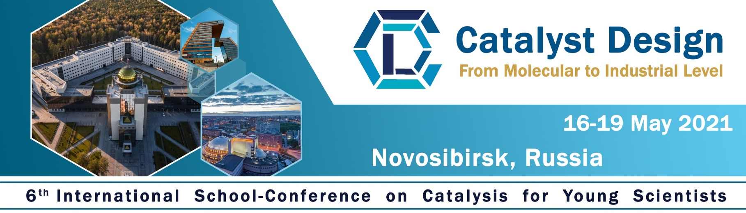
Dear colleagues and participants of the 6th International School-Conference on Catalysis for Young Scientists «Catalyst Design: From Molecular to Industrial Level»

To book a room at the Hotel «Golden Valley», please fill in this form and send it to Svetlana Logunova at logunova@catalysis.ru before April 30, 2021.

Name of participant(s):
Rooms | Price per night / per room (Rub) | Your choice
STANDARD single room | 2 430 Rub
Standard DOUBLE room  two separate beds | 3 760 Rub

Hotel «Golden Valley»
630090, Novosibirsk, Ilyicha st. 10
https://gold-valley.ru/

