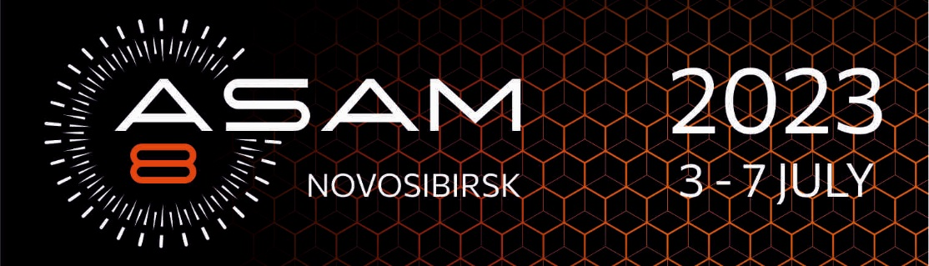

Dear colleagues!
To receive an invoice for the registration fee payment, please fill the form below and send it to Svetlana Logunova (logunova@catalysis.ru / or asam8@catalysis.ru).

Participant name:
Company name:
Company address:
e-mail:
Amount of registration fee:*

*
Participant | Registration fee (including VAT 20%)
 | April 10 – May 20, 2023
 | IN-PERSON | ONLINE
Full regular participant | 400 USD | 100 USD
Student, PhD student | 200 USD

CITIZENS OF CHINA CAN PAY THE REGISTRATION FEE IN YUAN.
Participant | Registration fee (including VAT 20%)
 | April 10 – May 20, 2023
 | IN-PERSON | ONLINE
Full regular participant | 1 200 CNY | 300 CNY
Student, PhD student | 600 CNY

