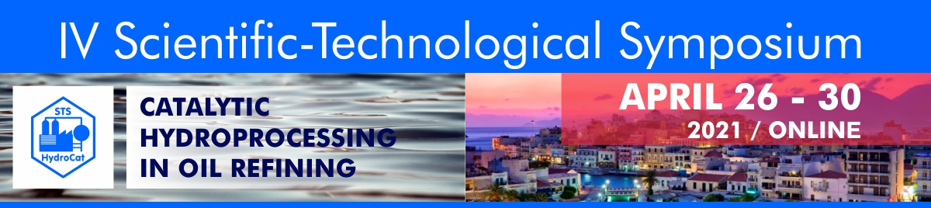
Dear colleagues!
To receive an invoice for the registration fee payment, please fill the form below and send it to Svetlana Logunova (logunova@catalysis.ru).

Participant name:
Company name:
Company address:
e-mail:
Amount of registration fee:*

*
Participant | Registration fee (including VAT 20%)
Full regular participant | 75 Euro
Student, PhD student | 50 Euro
Abstract publication | 25 Euro

