ANALISYS OF BRIGHTNESS EFFECT ON THE QUALITY OF PICTURES AFTER COMPRESSION WITH JPEG AND SPIHT COMPRESSION METHOD
B. Jakšić¹, B. Gara², R. Ivković¹, M. Petrović¹, M. Milošević³
¹Faculty of Technical Sciences, Kosovska Mitrovica, Serbia
² Ministry of Interior Republic of Serbia, Belgrade, Serbia
³ High school of Electrical Engineering and Computers, Belgrade, Serbia

ABSTRACT: In this paper we presented a comparison of objective quality of pictures after compression using two methods - JPEG and SPIHT. Methods are applied on pictures with different levels of brightness for different values of the bit rate (bpp) using software VCDemo. The quality of the compressed pictures is determined by values of MSE (mean square error), SNR (signal to noise ratio) and PSNR (peak signal to noise ratio). The values are presented in appropriate tables and diagrams. Based on the obtained data, we compared the quality of pictures with different brightness after compression. It was found that using compression gives better results compared with different levels of picture brightness. Presented below is how the quality of compression varies with the brightness pictures at different bit rates.

INTRODUCTION
Development of digital images led to the creation of several methods to store digital pictures. In order to reduce the size of storage needed for high resolution still digital images, it is necessary to perform compression and thus reduce the file size. Compression is the process of eliminating data redundancy or converting data into a form that occupies less storage space.
The JPEG (Joint Photographic Experts Group) method is a standard procedure for image compression. It is an established method for the compression of both black and white and coloured images in real (natural) scenes. It is used for the compression of natural images and paintings, but it is not efficient for the compression of text images, freehand or technical drawings. Together with GIF (Graphics Interchange Format), JPEG is the most popular format for transferring images over the Internet due to a satisfactory compression ratio and support by all web browsers for these file formats.
The JPEG method is used for the compression of still images and it belongs to the group of "intra-frame" compression methods. The similar standard – MPEG is used for the compression of moving images and it belongs to the group of “inter-frame” compression methods. In order to meet the diverse needs of many applications, the JPEG standard includes two basic compression methods: a DCT (Discrete Cosine Transformation) based method for "lossy" compression and a predictive method for "lossless" compression [1].
The "lossy" compression - called Baseline method - is the most widely implemented JPEG method. In the baseline mode, the image is divided into 8x8 pixel blocks and each of these is transformed using the DCT. The "power" of compression lies in the quantization of DCT coefficients with a uniform scalar quantizer, zig-zag scanning of the block and entropy coding using the Huffman code.
EZW (Embedded Zero-tree Wavelet) algorithm enables the progressive transmission of a compressed image. By using this algorithm, it is possible to stop the encoding process at any moment when the desired bit-rate is achieved. In the wavelet decomposition, the image is divided into sets of frequency/spatial hierarchical sub-bands. The important premise of the zero-tree algorithm is that substantial redundancy exists between the "parent" and "child" samples within the sub-band hierarchy [2].
EZW algorithm has very good PSNR (peak signal to noise ratio) performance compared to other compression algorithms with low bit-rates. It keeps significant coefficients in all levels. The main drawback of the EZW algorithm is its complexity, which impacts calculation resources [3, 4].
The EZW algorithm is used as a base for development of large number of similar compression methods. One of the most popular methods is SPIHT (Set Partitioning In Hierarchical Trees). In the original EZW method, arithmetic coding of the bit streams was essential in order to compress the ordering information as conveyed by the results of the significance tests.
Unlike the EZW, SPIHT doesn't use arithmetic coding. The subset partitioning is so effective and the significance information so compact that even binary un-coded transmission achieves similar or better performance than EZW. The reduction in complexity from eliminating the arithmetic encoder is significant.
The algorithm is introduced by Said and Pearlman [5] for the compression of still images. This method gives better results for larger compression ratios than EZW. The term "Hierarchical Trees" points to quad trees that consist of "parent" and "child" nodes as defined in EZW. Set Partitioning is the operation which divides wavelet coefficients from quad trees into partitions.
The algorithm selects the coefficients c_{i,j} such that, with n decremented in each pass, the coefficients are distributed into three ordered lists - List of Insignificant Sets (LIS), List of Insignificant Pixels (LIP) and List of Significant Pixels (LSP).
After initialization, the following steps are iterated: sorting pass, refinement pass and quantization step update. Through those steps the appropriate significance, sign, and most significant bits are sent to the decoder or stored on file.

THE MEASURES OF COMPRESSION QUALITY
Three of the most used measures for the comparison of image quality are the mean square error (MSE), signal to noise ratio (SNR) and peak signal to noise ratio (PSNR).
A method for the estimation of image quality is needed so as to give a view of how “lossy” compression methods modify image quality. We may treat an image as a matrix whose elements are image pixels.
The estimation process is then based on the calculation of distances between appropriate elements of input and output matrices. In this way, not only are the different qualities of the different compression methods compared, but also the results of the same methods using different compression ratios.
We denote the matrix A at the input of the compression system with elements a_{ij}, with i∈{1...M}, j∈{1...N}, where M is the number of image elements in the vertical and N is the number of image elements in horizontal direction [6]. MxN is the total number of image elements.
The output of the compression system is the matrix A' with elements a'_{ij}. The distance between the elements of matrices A and A' represents the error or the loss of image quality. Usually, the error is larger for higher compression ratios. A user can set the compression ratio according to the desired image quality, and hence directly influence the data size of the compression image [6].
The total reconstruction error is defined as:
(1)
The distance between the matrices A and A' is frequently calculated using the Mean Square Error:
(2)
Where MxN is the total number of image pixels, and the sum is applied to all image elements.
The amplitudes of image elements are in the range [0, 2^{n}-1], where n is the number of bits needed for binary representation of amplitude of each element in the original image. MSE does not consider amplitudes of image elements (it only considers differences between amplitudes) and it is the reason for introducing the Peak Signal to Noise Ratio
(3)
Where MxN is the total number of image pixels, and the sum is applied to all image elements.
The variable MAX_{I} is the maximum amplitude value of the image element (pixel). When the amplitude of the image pixel is represented by B bits, MAX_{I} is 2^{B}-1.
With n=8 bits/image element we can define:
(4)
Typical values for PSNR for “lossy” compressed images are between 30 and 50 dB.

SYSTEM MODEL
For analysis of objective image quality 8-bit uncompressed images saved in bmp format were used, with an original resolution of 512x512, 512x768 and 768x512 pixels available on the website: [http://sipi.usc.edu/database/misc.zip].
Images were brightened to various degrees using the illumination tool in Adobe Photoshop software [7]. Fig. 1 shows an example of one of the analyzed images with the original lighting and illuminated to 15%, 30%, 45%, 60% and 75% compared with the original, and its corresponding histograms are shown in Fig. 2.

a)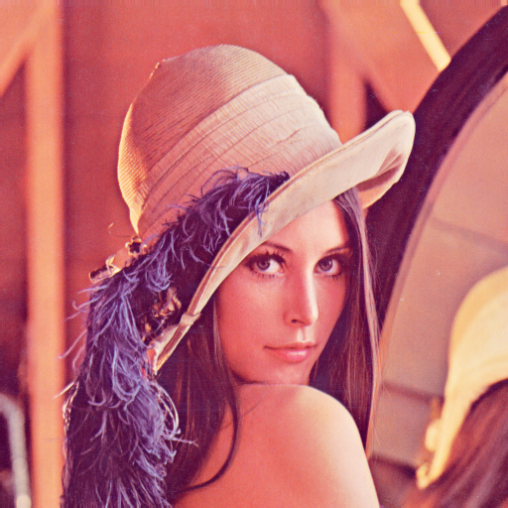 b)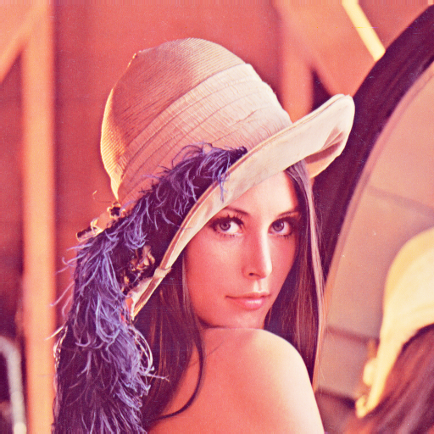 c)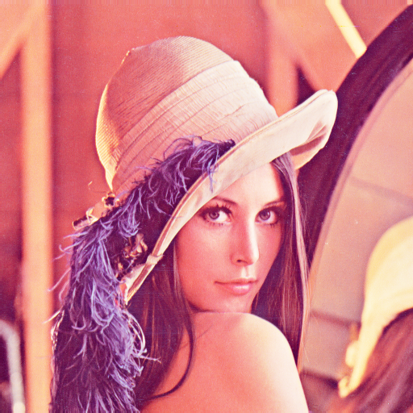 d)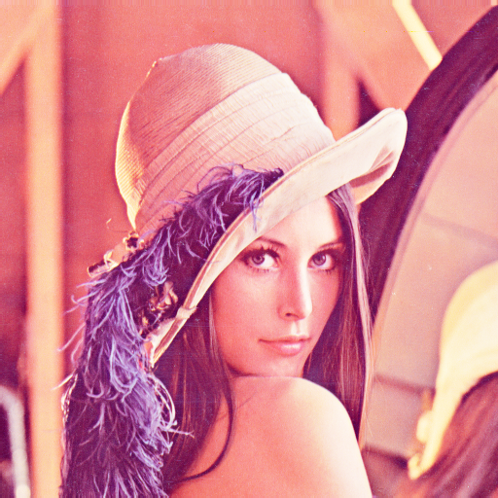

e)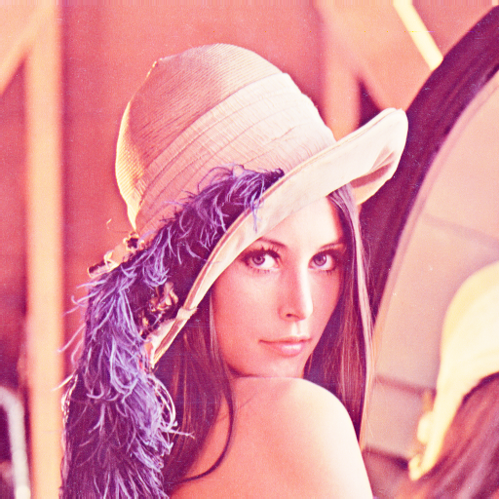 f)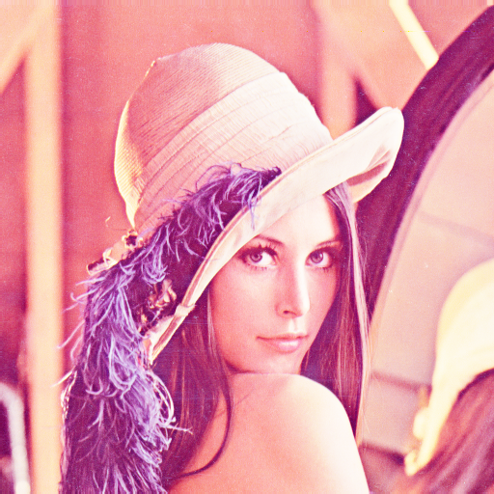

Fig. 1: An example of the analyzed image: a) original, b) illuminated 15% c) 30% illuminated, d) illuminated 45% e) 60% illuminated, f) 70% illuminated.

a)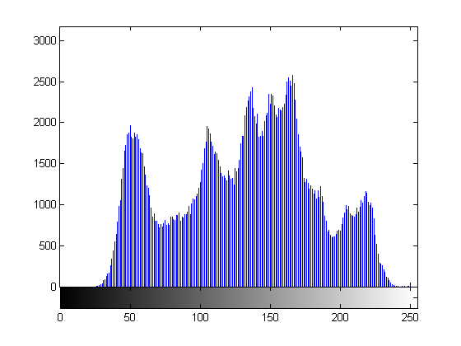
b)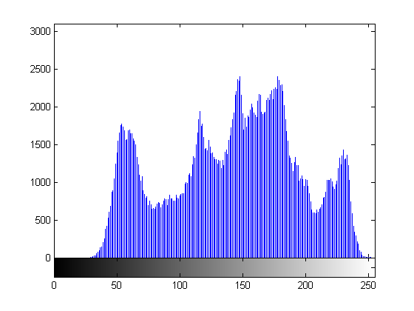
c)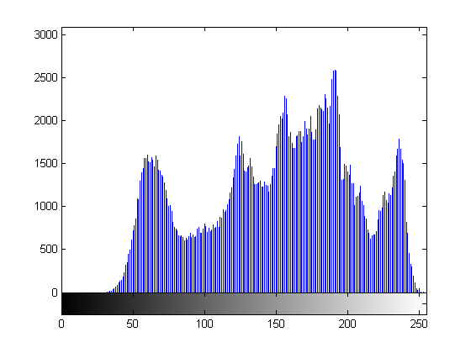
d)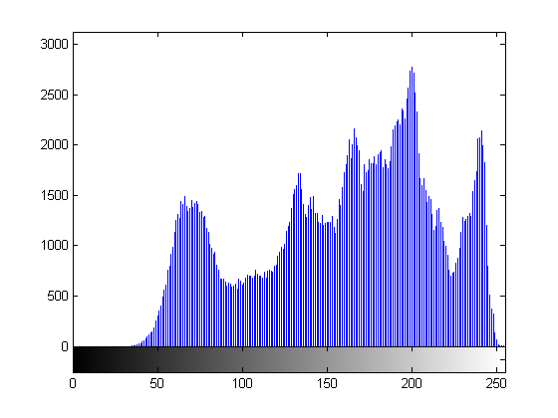
e)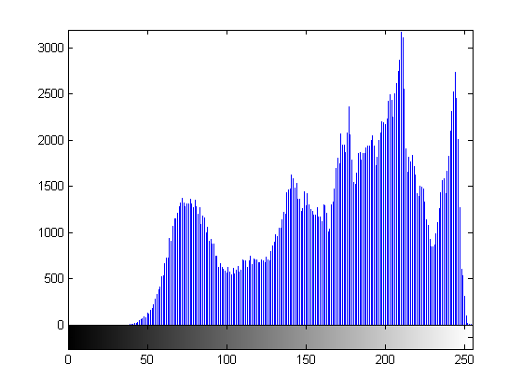
f) 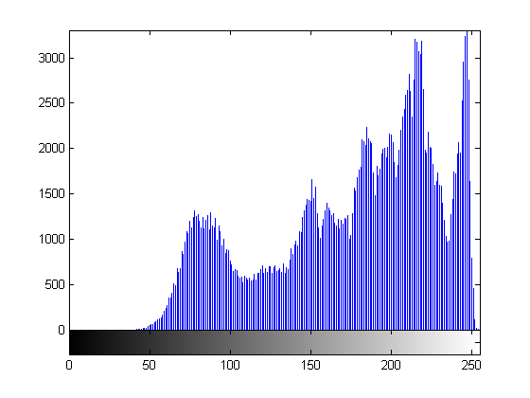

Fig. 2: Histogram of the analyzed image: a) original, b) illuminated 15% c) 30% illuminated, d) illuminated 45% e) 60% illuminated, f) 70% illuminated.

Image compression is performed in the software package VCDemo using modules for compression [8]. Nine bit rates were applied: 0.1, 0.2, 0.3, 0.4, 0.5, 0.7, 1.0, 1.5 and 3.0 bits / element images (bpp). Based on the differential between the original and the reconstructed images the mean squared error (MSE), signal/noise ratio (SNR) and peak signal/noise ratio (PSNR) were calculated.

RESULTS AND DISCUSSION
The JPEG compression values for different illuminated images are given in Table 1, Table 2 and Table 3, respectively. The graphic changes of PSNR with increasing bit rates in the JPEG compression method is presented in Fig. 3.

Table 1: Values of MSE for the JPEG compression method.

IMAGE | Bpp
IMAGE | 0.1 | 0.2 | 0.3 | 0.4 | 0.5 | 0.7 | 1 | 1.5 | 3
original | 416.7 | 106.1 | 49.9 | 32.8 | 25.1 | 17.5 | 12.2 | 7.6 | 3.0
15% | 398.9 | 110.0 | 54.4 | 37.4 | 29.0 | 20.6 | 14.2 | 8.9 | 3.1
30% | 397.3 | 115.6 | 61.4 | 41.1 | 31.6 | 22.1 | 15.5 | 9.9 | 3.2
45% | 399.6 | 117.1 | 63.5 | 42.7 | 33.1 | 23.6 | 16.4 | 10.4 | 3.2
60% | 410.4 | 119.6 | 65.4 | 44.1 | 35.0 | 24.5 | 17.6 | 11.3 | 3.1
75% | 418.0 | 121.6 | 66.5 | 45.3 | 36.1 | 25.4 | 18.2 | 11.7 | 3.1

Table 2: Values of SNR for the JPEG compression method.

IMAGE | bpp
IMAGE | 0.1 | 0.2 | 0.3 | 0.4 | 0.5 | 0.7 | 1 | 1.5 | 3
original | 7.8 | 13.8 | 17.0 | 18.8 | 20.0 | 21.6 | 23.1 | 25.2 | 29.3
15% | 8.4 | 14.0 | 17.1 | 18.7 | 19.8 | 21.3 | 22.9 | 25.0 | 29.5
30% | 8.6 | 14.0 | 16.7 | 18.5 | 19.6 | 21.2 | 22.7 | 24.6 | 29.6
45% | 8.6 | 13.9 | 16.6 | 18.3 | 19.4 | 20.9 | 22.5 | 24.4 | 29.6
60% | 8.5 | 13.8 | 16.4 | 18.1 | 19.1 | 20.7 | 22.1 | 24.1 | 29.6
75% | 8.3 | 13.6 | 16.3 | 17.9 | 18.9 | 20.4 | 21.9 | 23.8 | 29.6

Table 3: Values of PSNR for the JPEG compression method.

IMAGE | bpp
IMAGE | 0.1 | 0.2 | 0.3 | 0.4 | 0.5 | 0.7 | 1 | 1.5 | 3
original | 21.9 | 27.9 | 31.2 | 33.0 | 34.1 | 35.7 | 37.3 | 39.3 | 43.4
15% | 22.1 | 27.7 | 30.8 | 32.4 | 33.5 | 35.0 | 36.6 | 38.7 | 43.2
30% | 22.1 | 27.5 | 30.2 | 32.0 | 33.1 | 34.7 | 36.2 | 38.2 | 43.1
45% | 22.1 | 27.4 | 30.1 | 31.8 | 32.9 | 34.4 | 36.0 | 37.9 | 43.1
60% | 22.0 | 27.4 | 30.0 | 31.7 | 32.7 | 34.2 | 35.7 | 37.6 | 43.2
75% | 21.9 | 27.3 | 29.9 | 31.6 | 32.6 | 34.1 | 35.5 | 37.4 | 43.2

Fig. 3: Graphical dependence of peak signal / noise ratio (PSNR) for JPEG compression method.

From the given tables it can be seen that the MSE values decrease and the values of SNR and PSNR increase with increasing bpp for all images with different lighting conditions. At increased and decreased values of bpp, the changes in MSE are less pronounced in images with different lighting conditions.
From the graph shown in Fig. 3 and Table 3 it can be noted that at low values of bit rates, PSNR values are the same, and that an increase in the bit rates leads to a decrease in PSNR for the images with stronger lighting. At high bit rates values PSNR has again become the same regardless of the degree of image brightness.
The values of MSE, SNR and PSNR for different bit rates during compression using SPIHT for different illuminated images are given in Table 4, Table 5 and Table 6, respectively. Graphic changes of PSNR with increasing bit rates during compression SPIHT method are given in Fig. 4.

Table 4: Values of MSE for the SPIHT compression method.

IMAGE | Bpp
IMAGE | 0.1 | 0.2 | 0.3 | 0.4 | 0.5 | 0.7 | 1 | 1.5 | 3
original | 68.8 | 35.0 | 23.1 | 17.0 | 13.7 | 8.9 | 6.5 | 3.6 | 0.6
15% | 79.3 | 40.2 | 26.8 | 19.7 | 15.8 | 10.5 | 7.5 | 4.2 | 0.7
30% | 85.2 | 43.3 | 29.1 | 21.5 | 17.2 | 11.4 | 8.2 | 4.5 | 0.7
45% | 89.2 | 45.8 | 30.9 | 23.0 | 18.3 | 12.2 | 8.6 | 4.7 | 0.7
60% | 92.2 | 48.1 | 32.4 | 24.4 | 19.3 | 12.8 | 9.0 | 4.8 | 0.7
75% | 94.5 | 49.9 | 33.7 | 25.4 | 20.2 | 13.2 | 9.2 | 4.8 | 0.7

Table 5: Values of SNR for the SPIHT compression method.

IMAGE | Bpp
IMAGE | 0.1 | 0.2 | 0.3 | 0.4 | 0.5 | 0.7 | 1 | 1.5 | 3
original | 15.6 | 18.6 | 20.4 | 21.7 | 22.7 | 24.5 | 25.9 | 28.5 | 36.2
15% | 15.5 | 18.4 | 20.2 | 21.5 | 22.5 | 24.2 | 25.7 | 28.3 | 36.2
30% | 15.3 | 18.2 | 20.0 | 21.3 | 22.2 | 24.0 | 25.5 | 28.1 | 36.1
45% | 15.1 | 18.0 | 19.7 | 21.0 | 22.0 | 23.8 | 25.3 | 27.9 | 36.1
60% | 14.9 | 17.8 | 19.5 | 20.7 | 21.7 | 23.5 | 25.1 | 27.8 | 36.1
75% | 14.7 | 17.5 | 19.2 | 20.5 | 21.5 | 23.3 | 24.9 | 27.7 | 36.1

Table 6: Values of PSNR for the SPIHT compression method.

IMAGE | Bpp
IMAGE | 0.1 | 0.2 | 0.3 | 0.4 | 0.5 | 0.7 | 1 | 1.5 | 3
original | 29.8 | 32.7 | 34.5 | 35.8 | 36.8 | 38.6 | 40.0 | 42.6 | 50.3
15% | 29.1 | 32.1 | 33.9 | 35.2 | 36.1 | 37.9 | 39.4 | 41.9 | 49.8
30% | 28.8 | 31.8 | 33.5 | 34.8 | 35.8 | 37.5 | 39.0 | 41.6 | 49.6
45% | 28.6 | 31.5 | 33.2 | 34.5 | 35.5 | 37.3 | 38.8 | 41.5 | 49.6
60% | 28.5 | 31.3 | 33.0 | 34.3 | 35.3 | 37.1 | 38.6 | 41.4 | 49.6
75% | 28.4 | 31.1 | 32.9 | 34.1 | 35.1 | 36.9 | 38.5 | 41.4 | 49.8

From these tables it can be seen that, as in the case of JPEG compression methods, decreasing the value of MSE, PSNR, and SNR increase with increasing bit rates of all images with different lighting conditions.
Fig. 4: Graphical dependence of peak signal / noise ratio (PSNR) for SPIHT compression method.

Fig. 5: Graphical dependence of peak signal / noise ratio (PSNR) for JPEG and SPIHT compression method at different levels of brightness.

From the graph shown in Fig. 4 and Table 6, we can see that the PSNR increases with increasing bit rates. If we look at the level of image brightness, we can see that unlike JPEG compression methods, for lower values of bit rates, PSNR values are different. Only with high bit rate values do they have almost the same PSNR. The highest value of PSNR is in the original image and with increasing brightness, the PSNR decreases. The PSNR difference between a picture with different brightness values is most pronounced at a bit rate of 0.5.
Fig. 5 shows the PSNR comparison between JPEG and SPIHT compression methods for the most and the least illuminated image. The JPEG method gives lower PSNR values in comparison to the SPIHT method regardless of the level of light.

CONCLUSION
Based results obtained it can be concluded that the same quality compressed images at a higher bit rates, no matter how the image is illuminated. This applies to both the analyzed methods of compression. With a reduction in the bit rate, better quality is obtained for a darker image. At extremely low speed (0.1 bit / picture element) we get the same compression quality for the JPEG method regardless of image brightness. The SPIHT method continues to get better results in darker images than brighter images.
In terms of compression methods, in all analyzes the SPIHT method gives better results than the JPEG compression method.

LITERATURE

- Wallace G. K., The JPEG still picture compression standard, IEEE Trans. on consumer electronics, 38 (1992), No 1.
- Shapiro J. M., Embedded image coding using Zerotrees of wavelet coefficients, IEEE Trans. Signal Process. 41 (1993), No 12, pp. 3445–3462.
- Usevitch B. E., A Tutorial on Modern Lossy Wavelet Image Compression: Foundations of JPEG 2000, IEEE Signal Processing Magazine, September 2001.
- Malnar L., Kosović B., Batan J., Kompresija slike pomoću EZW algoritma, ZESOI, 2007.
- Pearlman W. A., Said A., New fast efficient image codec based on SPIHT, IEEE Transactions on Circuits and Systems for Video Technology, 6 (1996).
- Jančić M., Norme za kompresiju mirnih slika, FER, 2002.
- http://www.adobe.com/rs/products/photoshop.html.
- VCDemo, Delft University of Technology (TU-Delft) Faculty of Electrical Engineering, Mathematics, and Computer Science (EEMCS) ICT group, Delft, The Netherlands

ACKNOWLEDGMENT

This work was done within the research project of the Ministry of Science and Technological Development of Serbia III47016 and TR35026.

