COMPUTER OPTIMIZATION IN CHOOSING INTERNAL COMBUSTION ENGINE AND GEARBOX FOR GIVEN VEHICLE PERFORMANCE BY TRACTION DIAGRAM

Dundjerski I.¹ Matijevic D.¹ Dundjerski V.² Matijevic V.¹ Vukić D.¹

¹ School of Electrical Engineering and Computer Science Applied Studies, Belgrade, Serbia

² IT FUSION, Belgrade, Serbia

Design and construction modern motor vehicles in mass production are based on typified powertrain and joint platform in order to increase the competitiveness and lower product prices. Internal combustion engine and gearbox are adopted for vehicle in development from a range of finished products available in the market.
The article presents the optimization of selection internal combustion engine and gearbox by traction diagram toward those input parameters of the vehicle dynamics. During the process, the program performs the comparison between vehicle performance in development with the performance of the selected engine and gearbox obtained through traction diagram.The optimal choice is obtained according to the given criteria, related to the power and torque of the engine and transmission ratios. The program displays digital and analog results through tables and graphs.

Introduction

The first step in the design process a new motor vehicle is to define vehicle segment, areas of application and determination of output performance such as maximum speed, acceleration, time for reaching a certain speed, maximum climb, etc. Due to high competition, engineers have a very difficult task which requires the design of a new model for a short time. For large manufacturers that time is on average 18 months, which is many times shorter than the time that was previously available. In this complex process, the vehicle should be maximally adjusted to the market demands, that is often opposite of technical requirements. Therefore, this complex process always comes down to optimization, and not uniquely defining fulfillment of certain criteria to the maximum extent.
Large manufacturers of motor vehicles have sophisticated models in the design due to which it is possible to fulfill that complex task in a short period of time. The new model is typically constructed on a joint platform of other models, but the engine and transmission are chosen from the existing one on the market. Besides techno - economic requirements that must be met, there are also the environmental, which includes optimal emission and low fuel consumption. Therefore, it is important to optimally adjust the engine and transmission during the vehicle design stage.

Motor vehicles powered by internal combustion engine
Internal combustion engines with manual transmission are the most common types of powertrain in the motor vehicles despite a lack of spending scarce fossil fuels. They are characterized by high power per unit of weight, easy installation in the vehicle, easy start, and maintainability. With additional measures, today's engines have relatively low fuel consumption and specific systems for the treatment of exhaust gases.
In addition, the characteristics of the internal combustion engine are functionally different from the defined characteristics of an ideal powertrain.
Power required for moving the vehicle is defined by expression:
$P_{o}=M_{o}⋅ω_{t}=F_{o}⋅r_{d}⋅ω_{t}=F_{o}⋅V$ (1)
$F_{o}\underset{}{}\left[N\right]$ Motive force $ω_{t}\underset{}{}\left[\text{1/s}\right]$ Angular velocity of the wheel
$V\underset{}{}\left[\text{m/s}\right]$ Vehicle speed $r_{d}\underset{}{}\left[m\right]$ Dynamic radius of the wheel

Characteristic of the ideal powertrain provides maximum power to the drive wheels at all speeds, as shown in Figure 1a.
$P_{o}=F_{o}⋅V=P_{\text{max}}=\text{const}$ (2)
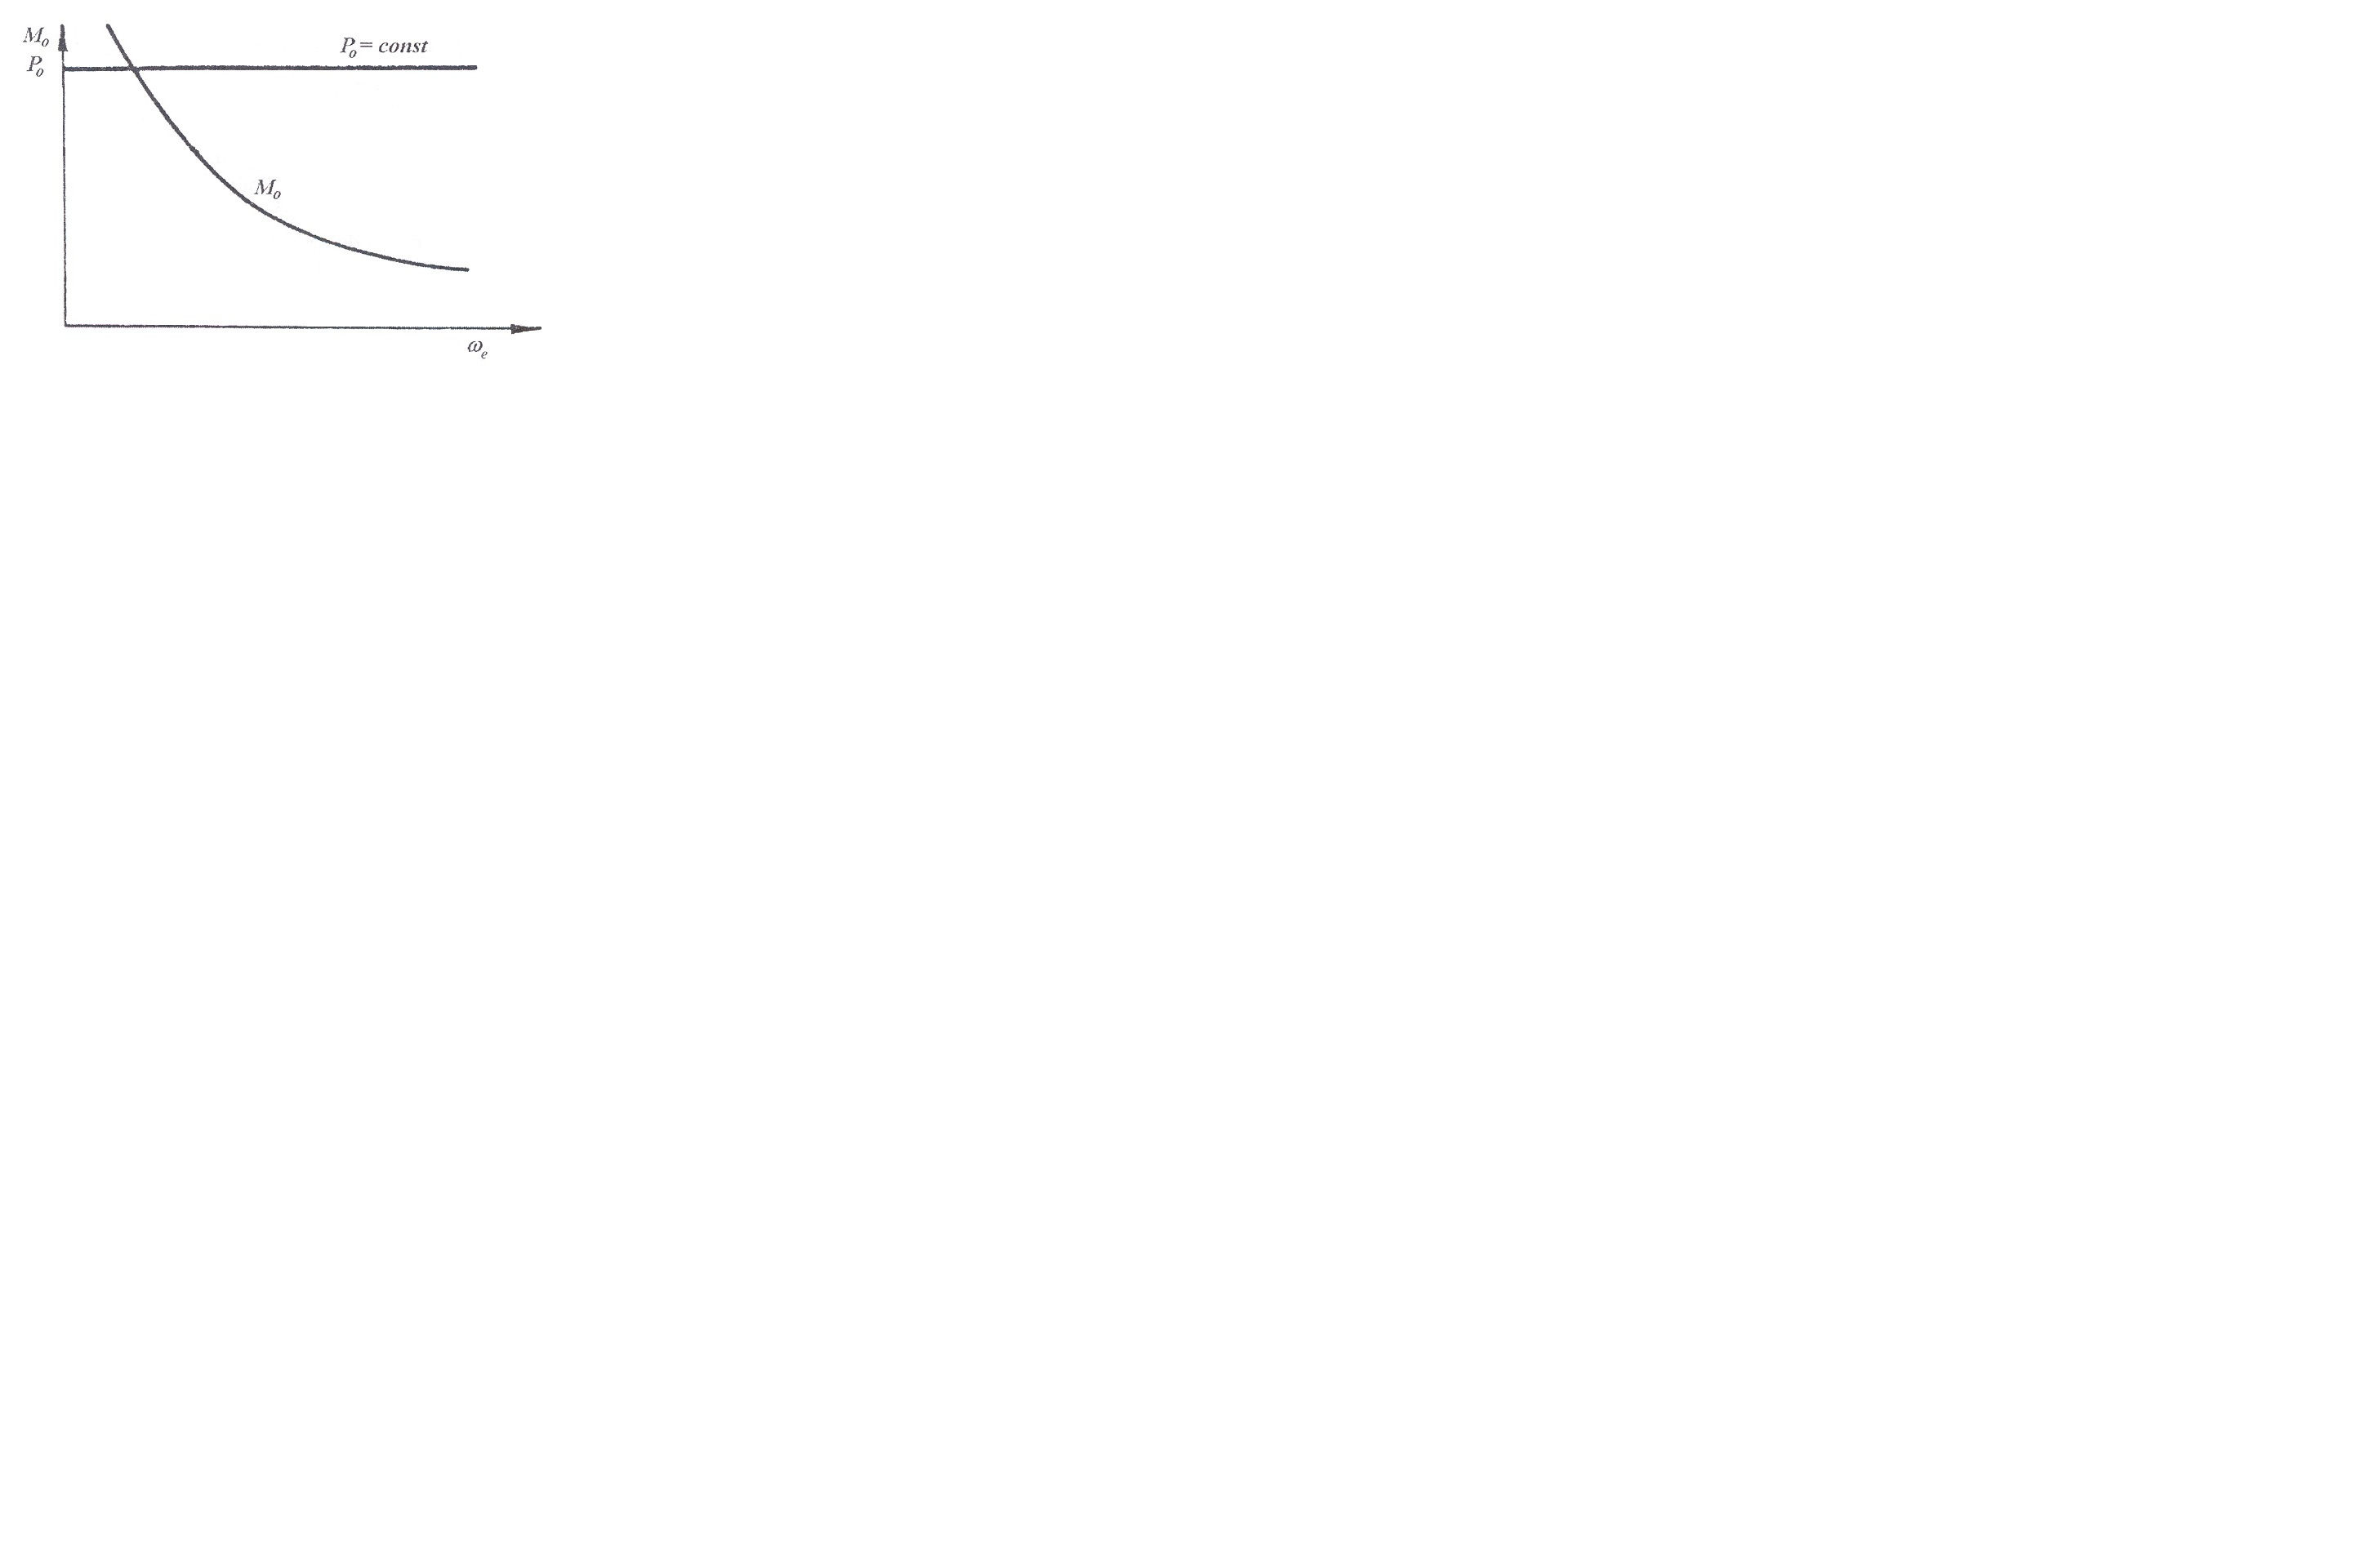
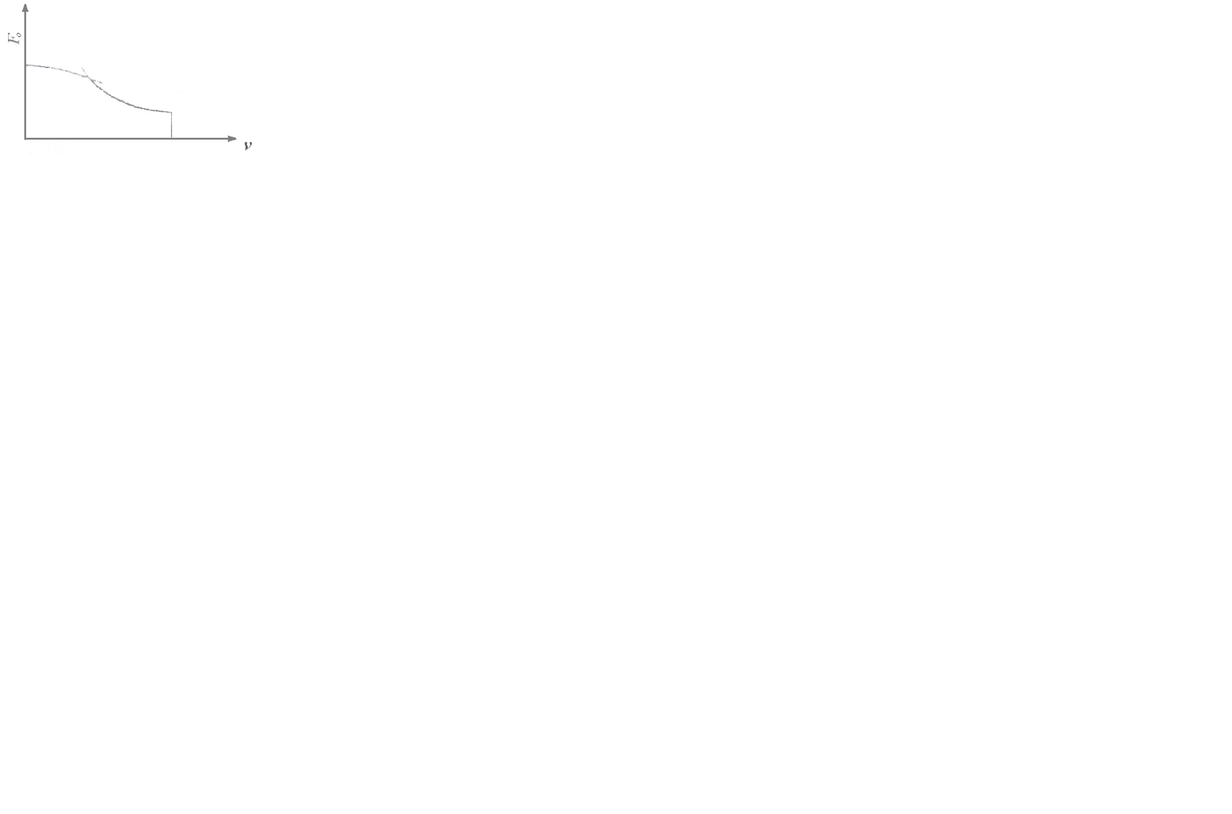

Fig.1a. Characteristic of the ideal powertrain Fig.1b. Characteristics of the ideal powertrain with limitations

Figure 1a. shows that the ideal characteristic of engine power is determined by a straight line and hyperbolic change of torque on the drive wheels, depending on the angular velocity.
Besides, it is important to note that the vehicle performances are not only affected by maximal engine power but also characteristics at partial load and different operating modes. This is dictated by the laws of the vehicle dynamics.
Despite the condition that motive force should be greater than the total resistance, there is also a condition that it should be less than the maximum longitudinal force of adhesion-dependent by coefficient of friction and normal load.
$X_{ϕ}=ϕ⋅Z_{ϕ}$ (3)

$X_{ϕ}\underset{}{}\left[N\right]$ Longitudinal force of adhesion
$ϕ\underset{}{}\underset{}{}\left[−\right]$ Coefficient of friction
$Z_{ϕ\underset{}{}}\left[N\right]$ Normal force
Therefore, the diagram in Figure 1a is corrected in accordance with the constraints of dynamic friction and maximum speed of the vehicle, as shown in Figure 1b.
Due to deviation speed characteristics of internal combustion engines from the ideal hyperbolic traction, desired performance can be achieved only by increasing the number of gear ratios, resulting in the complicated construction of gearbox to the limit of techno-economic feasibility.
Therefore it is very important to incorporate powertrain and vehicle, in fact make a right selection of appropriate engine and transmission on the market, according to the characteristics of the vehicle.

Program structure
The program is based on four criteria and contains a database of torque speed characteristics of internal combustion engines and transmission ratios of gearboxes that are widely used.

The input parameters of the program:
Axle to axle length: l_{o} [m] Mass of the empty vehicle: m_{s} [kg]
Vehicle width: B [m] Mass of the load: m_{k} [kg]
Vehicle height: h [m] Drag coefficient: c_{x} [-]
Ratio of the front longitudinal Dynamic radius of the wheel: r_{d} [m]
length to axle to axle length: l_{p}/l_{o} [%]
Height of center of gravity: h_{c} [m] Driving axle: front - rear
Output performance:
Maximal speed: V_{max} [m/s]
Maximal climb: u_{max} [%]
Climb in the highest gearing ratio: u_{V} [%]
Time for reaching 100 km/h: t₁₀₀ [s]

Criterion 1 – Maximal speed
Maximal speed is one of basic parameters to estimate traction-dynamic characteristics of vehicle. Furthermore, to the average buyer of motor vehicle maximal speed is the main criterion for the selection of vehicle. As the criteria for comparison of motor vehicles, maximal speed could be observed as number of ways, through the balance of power, pull balance or dynamic characteristic. In the article, the maximal vehicle speed is calculated over pull balance, comparing the drive torque of the engine to the moments of external resistances on the flywheel, depending on angular velocity flywheel.
For vehicle motion, motive force must be equal or higher than the sum of resistances:
$F_{o}=\sum{R}$ (4)
$F_{o}=R_{f}+R_{v}+R_{u}+R_{a}$ (5)
$\frac{M_{e}⋅i_{m}⋅i_{o}⋅η}{r_{d}}=m⋅g⋅f⋅\text{cos}α+\text{kA}⋅V^{2}+m⋅g⋅\text{sin}α+$ (6)
M_{e} [Nm] Engine torque on the flywheel
i_{m} [-] Gearbox transmission ratio
i_{o} [-] Final drive transmission ratio
m [kg] Mass of the vehicle
f [-] Rolling resistance coefficient
α [ ⁰] Road gradient
k [kg/m³] Reduced drag coefficient
A [m²] Equivalent frontal area of the vehicle
J_{tm} [kgm²] Moment of inertia of the drive wheel and rotating parts

The equation of the first criterion:
$M_{e}=\frac{r_{d}}{i_{m}⋅i_{o}⋅η}⋅\left[m⋅g⋅f+\text{kA}⋅V^{2}\right]$ (7)
Calculation of the maximum speed includes straight road without climbing, and since the speed is constant there is no acceleration. For selected maximum speed and transmission, program defines the torque curve of sum of resistance and compared it with the drive torque, seeking for their intersection, point B in Figure 2.
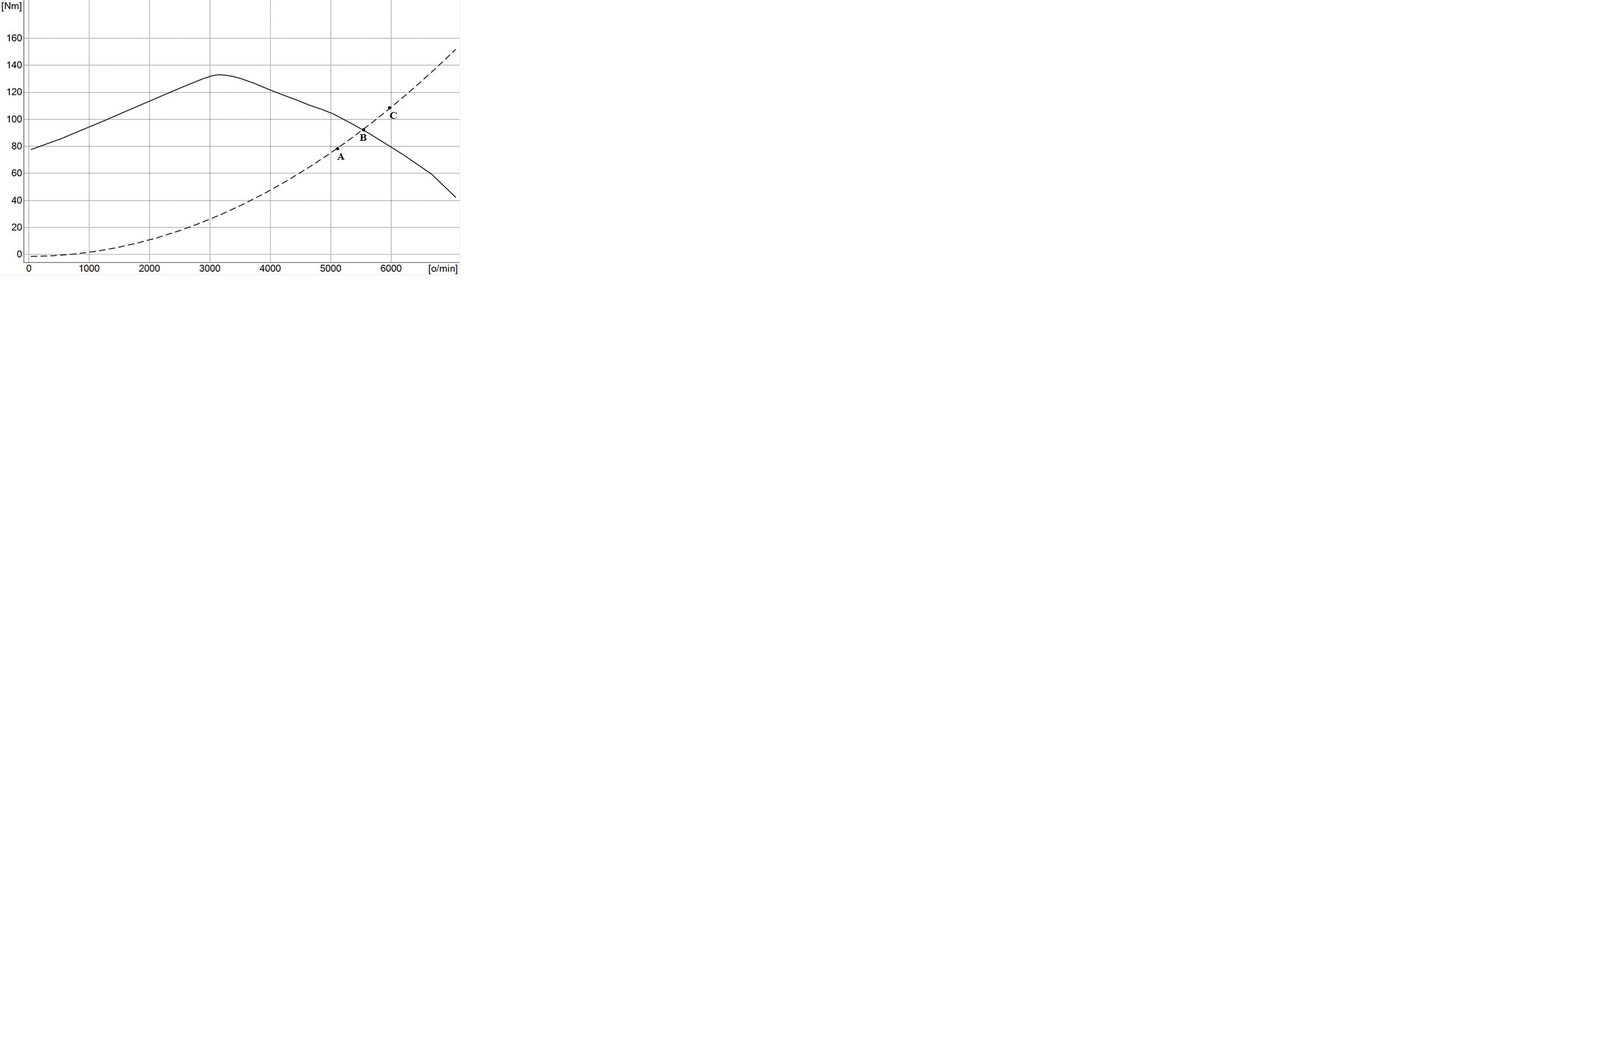

Fig.2. Dependence drive torque and torque of sum of resistance from engine speed

If the point C on the resistance curve is determined by maximal speed from input parameters, M_{eC}>M_{eB} , it is evident that powertrain could not achieve desired speed for defined vehicle parameters. This means that for the given powertrain, criterion 1- the maximal speed of the vehicle is not fulfilled. If the point A on the resistance curve is determined by maximal speed from input parameters, M_{eA}<M_{eB} , even at maximum speed engine has a torque reserve, what provides that criterion 1 – the maximal speed of the vehicle is fulfilled.
Assessment, how maximal speed that vehicle can develop is close to the specified speed from input parameters is defined through coefficient of evaluation:
$δ_{\text{ij}}^{I}=\frac{{\text{Me}}_{B}}{{\text{Me}}_{A}}>1$ (8)
Coefficient of evaluation index consists of:
Upper index “I” - provides the number of criteria
First under index “i” - engine number from the database
Second under index “j”- gearbox number from the database

If the value of the coefficient of evaluation closer to 1, the powertrain is more responsive to the demands of designer according to the criterion of maximum speed, and if the coefficient is less than 1, criteria 1 - maximal speed cannot be achieved, so the possibility of considering the observed combination through further calculation rejects.

Criterion 2 – Maximal climb
Climbing resistance is a component of force of gravity and it is parallel to the road surface with the opposite direction to the direction of movement. Road climb is usually expressed through tgα, and not through sinα :
$u\left[\text{\%}\right]=\text{100}⋅\text{tg}α$ (9)
For small values of road climb, for angles around 10 – 12 ⁰, it could be adopted without greater mistake $\text{tg}α≈\text{sin}α$.
For larger angles this approximation can lead to significant error.
Rolling resistance coefficient and road climb are the main parameters that define the characteristics of the road from the standpoint of the resistance.
Sum of resistances for maximal road climb, $R_{ψ}$ is defined by expression (10):
$R_{ψ}=G⋅\left(f⋅\text{cos}α_{\text{max}}+\text{sin}α_{\text{max}}\right)=G⋅ψ_{α\text{max}}$ (10) $ψ_{α\text{max}}$ [-] coefficient of sum of resistances

Motive force $F_{o\text{max}}$or propulsive force of vehicle, is defined by expression (11):
$F_{o\text{max}}=\frac{M_{e\text{max}}⋅η⋅i_{o}⋅i_{I}}{r_{d}}$ (11)
$i_{I}$ [-] Transmission ratio in the first gear
The first condition that program sets is comparing value of motive force with value of sum of resistances. If $F_{o\text{max}}<R_{ψ}$- the possibility of considering the observed combination through further calculation rejects.
The second condition involves the determination limit of adhesion, which requires defining normal load on the drive axle.
Normal force in the case of front drive axle:
$Z_{pϕ}=\frac{G⋅\text{cos}α⋅\left(l_{z}+h_{c}⋅f\right)}{\left[l_{o}+\left(f+ϕ\right)⋅h_{c}\right]}$ (12)
Normal force in the case of rear drive axle:
$Z_{zϕ}=\frac{G⋅\text{cos}α⋅\left(l_{p}−h_{c}⋅f\right)}{\left[l−\left(f+ϕ\right)⋅h_{c}\right]}$ (13)
Longitudinal force of adhesion:
$X_{ϕ}=ϕ⋅Z_{ϕ}$ (14)
After determination longitudinal force of adhesion, program is comparing it with sum of resistances. If $X_{ϕ}<R_{ψ}$, specified climb cannot be overcome due to the structural characteristics of the vehicle, or insufficient normal load on the drive axle, or insufficient coefficient of friction, whose value is adopted to match to the good asphalt ($ϕ=0,\text{85}$). In that case, program shows in output data maximal climb that vehicle can overcome.
If both conditions are fulfilled it is necessary to determine the maximal climb u_{Imax} and compare it with required climb from input parameters u_{max}, in order to define coefficient of the evaluation of this criterion.
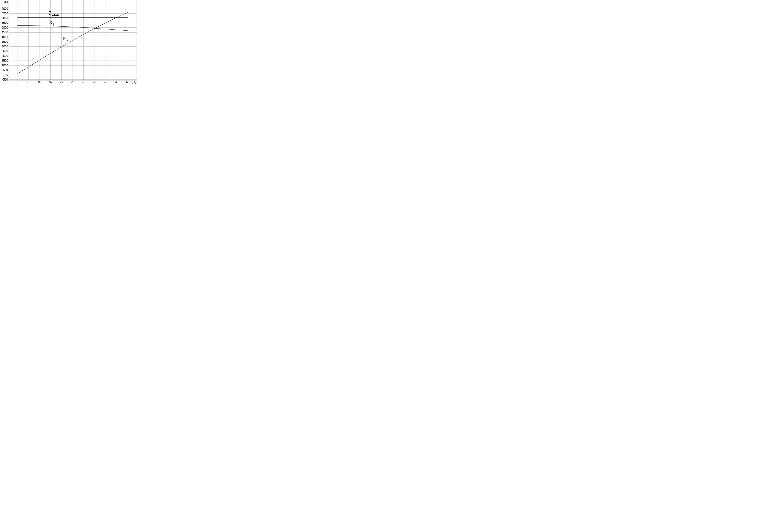
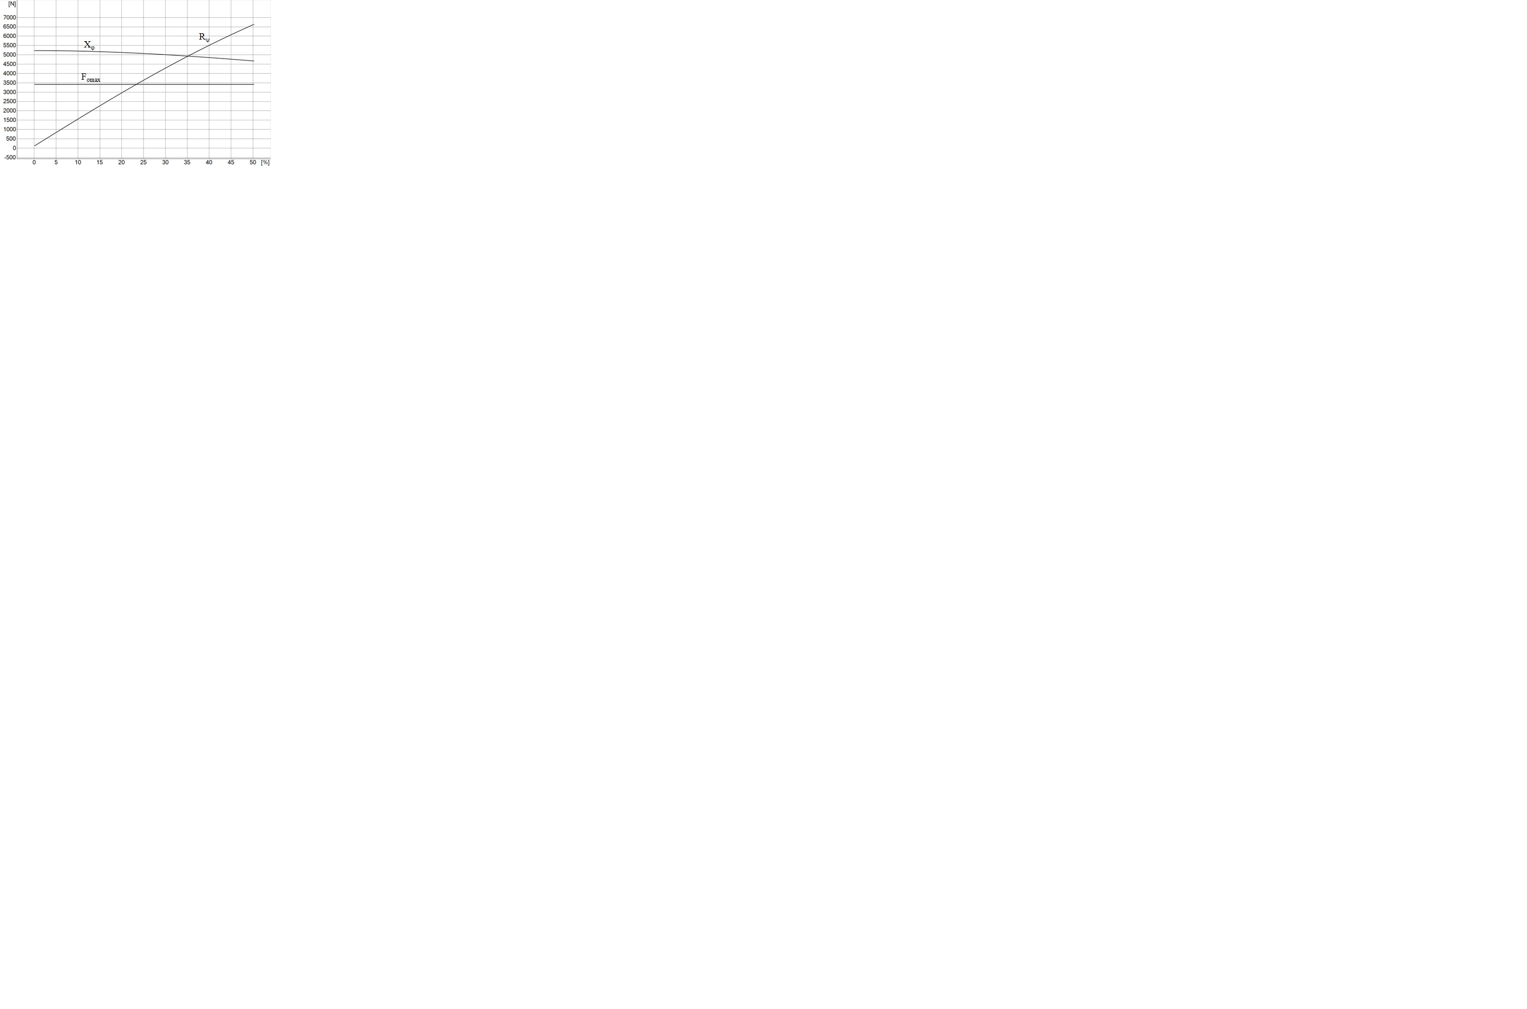

Fig.3a. Dependence sum of resistances, motive force and longitudinal force of adhesion from road climb (longitudinal force of adhesion greater than motive force)
Fig.3b. Dependence sum of resistances, motive force and longitudinal force of adhesion from road climb (longitudinal force of adhesion less than motive force)

In Figures 3a. and 3b. is shown the method of determining maximal climb that vehicle can overcome.
In Figure 3a. the resistance curve $R_{ψ}$ first intersects the curve of motive force$F_{o\text{max}}$, which means that the maximal climb is limited by engine torque.
In Figure 3b. the resistance curve first intersects the curve of longitudinal force of adhesion, which means that the maximal climb is limited by the structural characteristics of the vehicle.
Coefficient of evaluation for second criterion indicates how many times is maximal climb that vehicle can overcome u_{Imax} larger than required climb from input parameters u_{max}.
$δ_{\text{ij}}^{\text{II}}=\frac{u_{\text{Im}\text{ax}}}{u_{\text{max}}}$ (15)

Criterion 3 – Maximal climb in the last gear
Criterion 3 estimates excess of traction upon overcoming a road climb in the last gear.
Block diagram, shown in Figure 4, presents a procedure for determining maximal climb for the vehicle in the last gear (for gearbox with five gears).
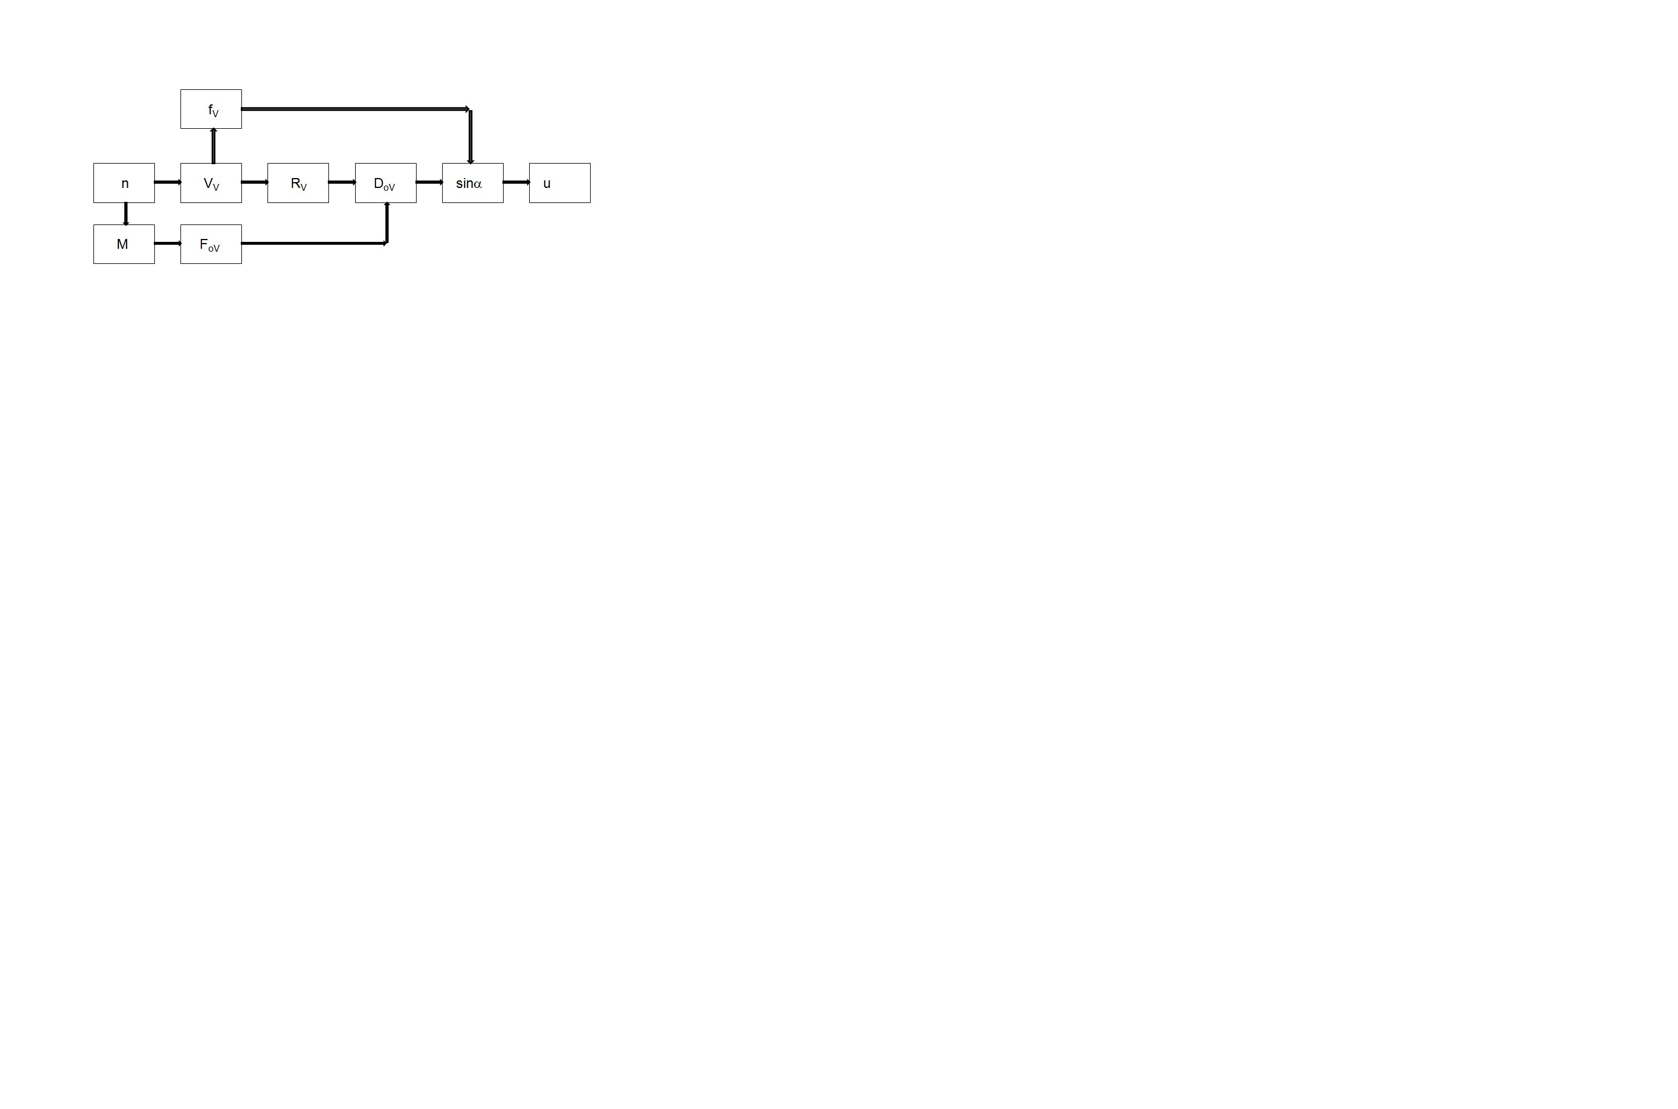
Fig.4. – Block diagram for determining maximal climb in the last gear

D_{oV} [-] dynamic characteristic in the last gear

Soviet academician E.A. Chudakov introduced dynamic characteristic after noticing the problem that two cars with the same motive forces, at the same speed, but with different weights, couldn't have the same traction characteristics. Dynamic characteristic includes the impact of aerodynamic drag and weight of a vehicle, using the fact that all resistances, except aerodynamic drag, are proportional to the mass of the vehicle.
$D_{\text{oV}}=\frac{F_{\text{oV}}−R_{v}}{G}$ (16)
Maximal climb is obtained through expression (17) in dependence of dynamic characteristic and rolling resistance coefficient.
$\text{sin}α=\frac{D_{o}−f⋅\sqrt{1−D_{o}^{2}+f^{2}}}{1+f^{2}}$ (17)
The coefficient of evaluation of the third criterion is formed as a ratio of maximal climb that vehicle can overcome in the last gear u_{Vmax}, and the set climb from input parameters u_{V}, under the condition $u_{V\text{max}}>u_{V}$.
$δ_{\text{ij}}^{\text{III}}=\frac{u_{V\text{max}}}{u_{V}}$ (18)

Criterion 4 – Time for reaching a speed of 100km/h
The fourth criterion is determination the time for reaching a speed of 100 km/h, because that performance is often referred in technical description of the vehicle.
Time for reaching a certain speed is usually obtained with graphic and analytical methods using diagram$1/a=f(V)$. Result is calculated as integral of the areas$t_{z}=\int_{V_{1}}^{V_{2}}{\frac{1}{a}\text{dV}}$.
The article presents other method of calculation the time for reaching a certain speed, where that time presents sum of elemental time periods from 0.1s, starting from set speed on the diagram of dependence engine torque from engine speed, on the basis of which the motive force is calculated and then also the acceleration. The gear changes occur when the motive force in actual gear becomes lower than it would be in higher gear$F_{\text{oi}}<F_{\text{oi}+1}$.

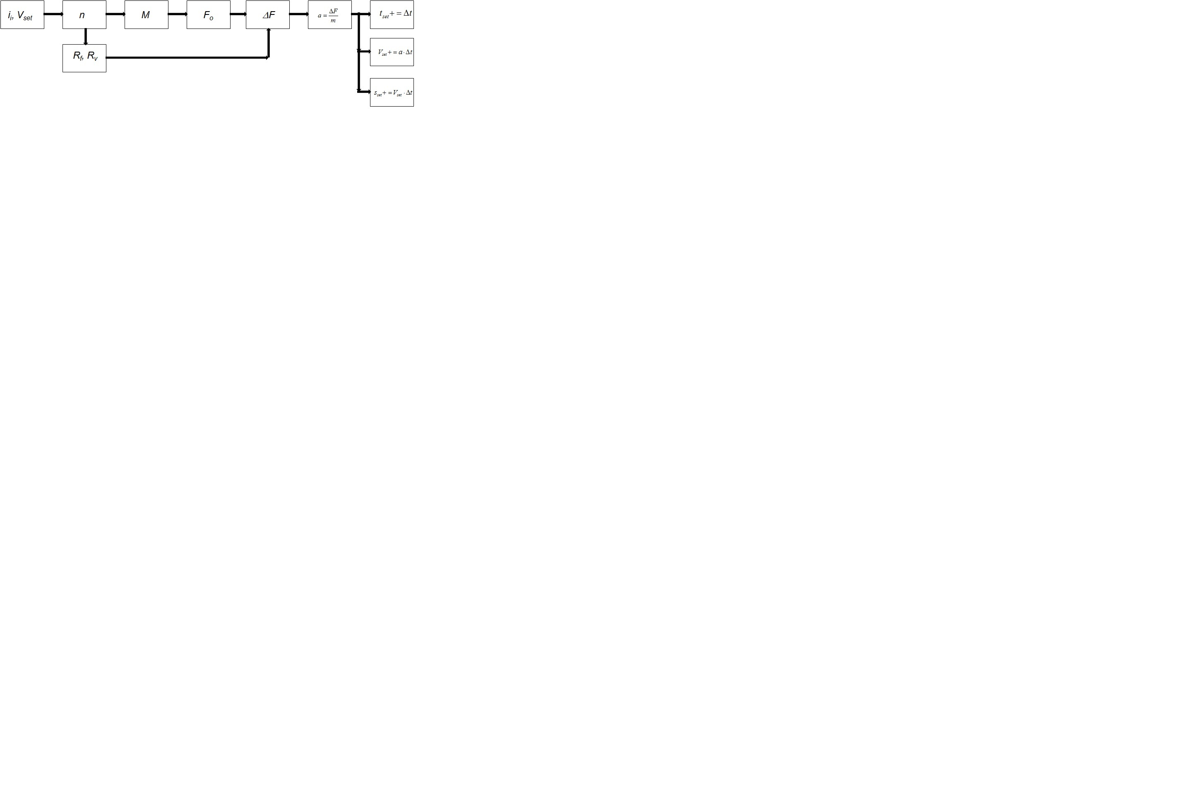
Fig.5 - Block diagram for determining the time for reaching a certain speed

The criterion is fulfilled when obtained time is less than desired time in input parameters$t_{\text{100}}>t_{\text{100}\text{actual}}$.
The coefficient of evaluation of the fourth criterion:
$δ_{\text{21}}^{\text{VI}}=\frac{t_{\text{100}}}{t_{\text{100}\text{actual}}}$ (19)

Output data of the program
Based on the coefficients of evaluation the program calculates the final coefficient,which evaluates all four with weighting factors:
$δ_{\text{ij}}=0,\text{25}⋅δ_{\text{ij}}^{I}+0,\text{25}⋅δ_{\text{ij}}^{\text{II}}+0,\text{25}⋅δ_{\text{ij}}^{\text{III}}+0,\text{25}⋅δ_{\text{ij}}^{\text{IV}}$ (20)
With the weighting factors some criteria can be evaluated with greater priority than the others. Because of that, the user has a possibility to change the weighting factors. All four criteria can be evaluated with equal priority, as shown with expression (20). Optimal combination of engine and gearbox is the one with the lowest value of final factor.
As a final result, the program shows a traction diagram for vehicle with optimal powertrain, as shown in Figure 6.
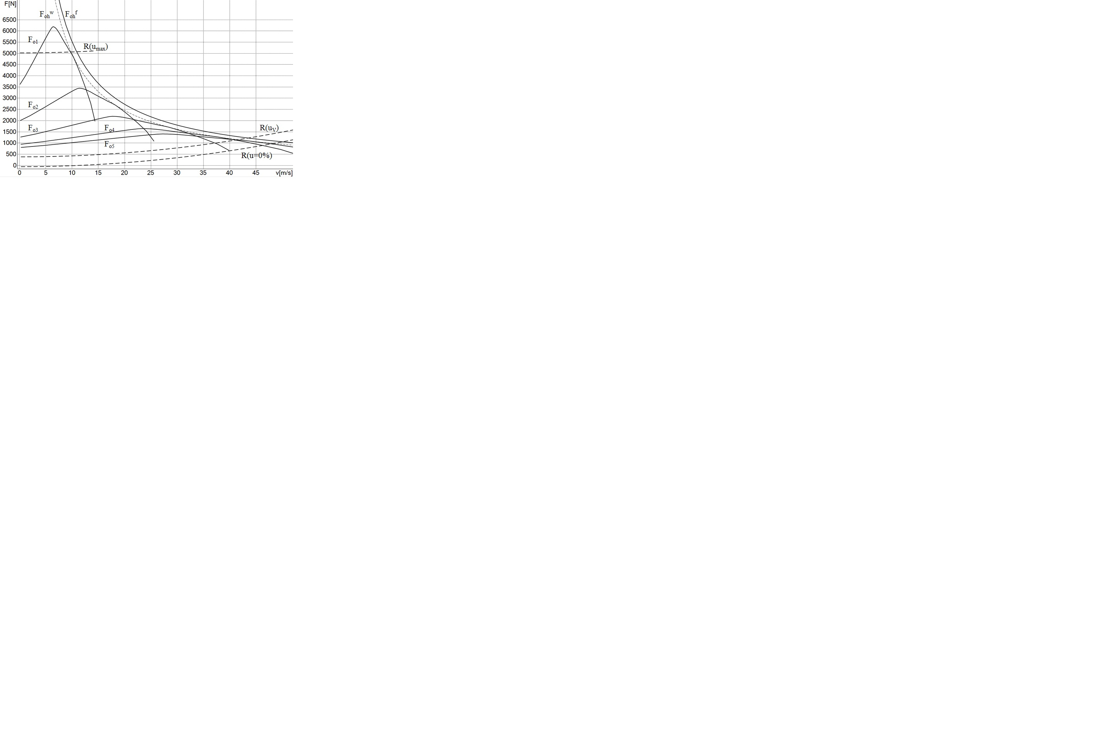
Fig. 6. Traction diagram for vehicle with optimal powertrain
Traction diagram presents graphic interpretation of pull balance, displaying resistance forces and motive forces in dependence of vehicle speed. It also shows the ideal characteristic of the vehicle - hyperbole of traction.
Hyperbole of traction on the flywheel:
$F_{\text{oh}}^{f}=\frac{P_{e\text{max}}}{V}$ (21)
Hyperbole of traction on the drive wheels:
$F_{\text{oh}}^{w}=\frac{P_{e\text{max}}⋅η}{V}$ (22)

Conclusion
The article presents a program for optimal choice the internal combustion engine and gearbox, for vehicle in the design stage toward traction and dynamic characteristics. Program is based on four criteria: maximal speed, maximal climb, maximal climb in the last gear, time for reaching a speed of 100 km/h, so accordingly determines the right combination of engine and gearbox from database.
The database is constantly updated with new engines and gearboxes. The program can be improved and supplemented with additional criteria. This program evaluates only traction and dynamic characteristics of vehicles that do not include fuel consumption. But since the CO₂ emission is global issue, directly related to the fuel consumption, in future program could be improved also with this criteria. In addition, it is possible to upgrade the program to evaluate other kinds of powertrain, not just internal combustion engines, than hybrid and electric drive, which are much closer to the ideal hyperbole of traction. Adjustment of certain criteria, introducing resistance trailers into consideration it is possible to adapt program to work with commercial vehicles also.

Literature :
1. Janković D. Ivanović G. Todorović J. Rakićević B. Teorija kretanja motornih vozila, Mašinski fakultet u Beogradu 2001.
2. Simić D. Motorna vozila, Naučna knjiga Beograd 1977.
3. Janković. D. Uputstva za izradu vučnog proračuna motornih vozila, Mašinski fakultet Beograd 1992.
4. Robert Bosch, Driving Stability System, Plochingen 2005.
5. Tomić M. Petrović S. Motori sa unutrašnjim sagorevanjem, Mašinski fakultet
Beograd 2009

