APPLIED STATISTICS IN PROCESS CONTROL AND MONITORING.
S. M. Draškovićˡ, Ž. M. Đurović², E. A. Kisićˡ
ˡ School of Electrical Engineering and Computer Science of Applied Studies, Belgrade, Serbia
² School of Electrical Engineering, University of Belgrade, Belgrade, Serbia

In modern industrial processes the main task is process control and monitoring. Statistical process control is a powerful collection of problem-solving tools useful in achieving process stability through the reduction of variability. In this paper are presented control charts as the most sophisticated tool of statistical process control. After the general theory of control charts the results obtained from control charts which were applied on real process in thermal power plant are presented. A discussion about the advantages of the control charts application in industrial processes is given.

Introduction

Process control and monitoring are becoming essential tasks in nowadays industry. Today, all processes are automatized and they contain a lot of sensors and actuators. Because of that, the control of these processes is sometimes very difficult.
Statistical process control (SPC) is a powerful collection of problem-solving tools useful in achieving process stability and improving capability through the reduction of variability. SPC can be applied to any process. It has seven major tools, but the control chart is the most technically sophisticated. It was developed in the 1920. by Walter A. Shewhart [1] of the Bell Telephone Laboratories. Since then many types of control charts were developed and univariate SPC is extended to multivariate SPC when there is need for monitoring more than one variable. Control charts have had long history of use in industries.
There are many reasons for their popularity. Control charts are a proven technique for improving productivity, as they are effective in defect prevention, they prevent unnecessary process adjustment, they also provide diagnostic information and they provide information about process capability. Modern computer technology has made it easy to implement control charts in any type of process, as data collection and analysis can be performed on a microcomputer or a local area network terminal in real time.
Тhe main purpose of the control chart is to improve the process. In practice it is generally found that most processes work out of statistical control. Routine and careful use of control charts may help in successful identification of failures. If the causes of failures can be eliminated, variability will be reduced, and consequently the process will be improved [2].
This paper is structured as follows: in the next section we present the general theory of univariate control charts. In section 3 the brief theoretical review of multivariate control charts is given. In section 4 we present the application of univariate control charts in thermal power plant “Nikola Tesla”. In section 5 the conclusion and a short discussion about the advantageous and the shortcomings of the application of control charts in industrial processes and possible solutions to problems encountered are presented.
Univariate control charts
The control chart is a statistical tool for fault detection in the system. Control charts make a clear difference between changes that are result of numerous, always present immeasurable disturbances in the process and changes that are the result of system fault. Generally speaking, control charts present graphical display of regular, e.g., irregular operation mode of process during time.
In any production process, regardless of how well it is designed and maintained, a certain amount of inherent or natural variability will always exist. This natural variability or "background noise" is the cumulative effect of many small, essentially unavoidable causes. In
the framework of statistical quality control, a system that has this natural variability is often called a "stable system of common causes". A process that is operating with only common causes of variation is said to be in statistical control. In other words, the common causes are an inherent part of the process. Other kinds of variability may occasionally be present in the output of the process. Such variability is generally large when compared to the background noise, and it usually represents an unacceptable level of process performance. We refer to these sources of variability that are not part of the chance cause pattern as "special causes". A process that is operating in the presence of special causes is said to be out of control.
The control chart is a graphical display of a quality characteristic that has been measured or computed from a sample versus the sample number or time. A typical control chart contains a center line that represents the average value of the quality characteristic corresponding to the in-control state, e.g. only common causes are present. Two other horizontal lines, called the upper control limit (UCL) and the lower control limit (LCL), are also shown on the chart. These control limits are chosen so that if the process is in control, nearly all of the sample points will fall between them. It is customary to connect the sample points on the control chart with straight-line segments, so that it is easier to visualize how the sequence of points has evolved over time. On figure 1 typical control chart is shown.

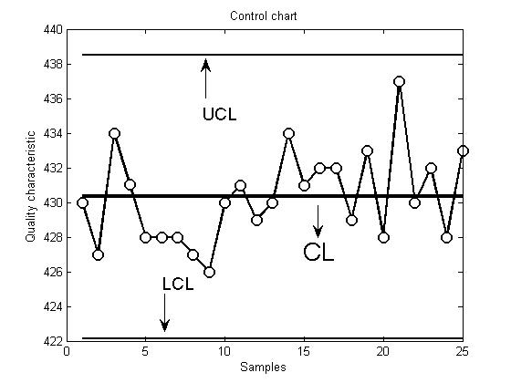
Fig. 1- Typical control chart

Even if all the points fall inside the control limits, if they behave a systematic or nonrandom manner, then this could be an indication that the process is out of control. If the process is in control, all the plotted points should have an essentially random pattern.
There is a close connection between control charts and hypothesis testing. The control chart is a test of the hypothesis that the process is in a state of statistical control. A point plotting within the control limits is equivalent to failing to reject the hypothesis of statistical control. One place where the hypothesis testing framework is useful is in analyzing the performance of a control chart. For example, we may think of the probability of type I error of the control chart (concluding the process is out of control when it is really in control) and the probability of type II error of the control chart (concluding the process is in control when it is really out of control).
We now may give a general model for a control chart. Let w be a sample statistic that measures some quality characteristic of interest, and suppose that the mean of w is $μ_{w}$ and the standard deviation of w is $σ_{w}$. Then the center line, the upper control limit, and the lower control limit become
$\begin{aligned}\text{UCL}=μ_{w}+{Lσ}_{w} \\ \text{CL}=μ_{w} \\ \text{LCL}=μ_{w}−{Lσ}_{w}\end{aligned}$ (1)
where L is the "distance" of the control limits from the center line, expressed in standard deviation units. This general theory of control charts was first proposed by Walter A. Shewhart, and control charts developed according to these principles are often called Shewhart control charts.
Specifying the control limits is one of the critical decisions that must be made in designing a control chart. By moving the control limits further from the center line, we decrease the risk of a type I error. However, widening the control limits will increase the risk of a type II error. Commonly practice is to take for L to be L=3 making three-sigma control limits. If the distribution of the quality characteristics is reasonably approximated by the normal distribution, then it is assumed that 99.7% of points will fall inside the control limits while the system is in statistical control. In this way it is made good balance between type I error and type II error.
The first step in constructing the control chart requires analysis of preliminary data set which is assumed to be in statistical control. This phase is called phase I. In this phase it is very important to establish reliable control limits for phase II. In phase II, we use the control chart to monitor the process by comparing the sample statistic for each successive sample as it is drawn from the process to the control limits.
Performance of the control chart can be expressed in terms of its average run length (ARL). Essentially, the ARL is the average number of points that must be plotted before a point indicates an out of control condition. If the process observations are uncorrelated, then for any Shewhart control chart, the ARL can be calculated easily from
$\text{ARL}=\frac{1}{p}$ (2)
where p is the probability that any point exceeds the control limits. That means for three-sigma control limits, p = 0.0027 is the probability that a single point falls outside the limit when the proces is in control and ARL=370. That is, even if the process remains in control, an out-of-control signal will be generated every 370 samples, on average.
When we monitor only one qualitative characteristic of interest, we use univariate control charts. There are many types of control charts which can be chosen depending on the nature of the process [2]. In this paper is performed univariate analysis with MR (Moving Range) chart for individual measurements which actually contains two charts-upper chart is chart for individual measurements and lower chart is MR chart.
In many applications of the individuals control chart we use the moving range of two successive observations as the basis of estimating the process variability. The moving range is defined as
${\text{MR}}_{i}=|x_{i}−x_{i−1}|$ (3)
Let the $\overline{\text{MR}}$ be mean value of all moving ranges and $\overline{x}$ mean value of samples. Then the control lines for control chart for individual measurements are:
$\begin{aligned}\text{UCL}=\overline{x}+3{\overline{\text{MR}}}/{d_{2}} \\ \text{CL}=\overline{x} \\ \text{UCL}=\overline{x}+3{\overline{\text{MR}}}/{d_{2}}\end{aligned}$ (4)
Control lines for MR control charts are:
$\begin{aligned}\text{UCL}=D_{4}\overline{\text{MR}} \\ \text{CL}=\overline{\text{MR}} \\ \text{LCL}=D_{3}\overline{\text{MR}}\end{aligned}$ (5)
All constants in formulas (4) and (5) are in look up tables and depend on sample size [2].

Multivariate control charts

When we monitor more qualitative characteristics which are correlated, we use multivariate control charts which take this correlation into account. We can find in literature T² [3], MEWMA [4] and MCUSUM [5] control charts. In this paper the brief theoretical review of T² multivariate control charts and MEWMA control charts is given.
The most familiar multivariate process-monitoring and control procedure is the Hotelling T² control chart for monitoring the mean vector of the process. Hotelling was first to propose a multivariate control chart based on a statistical distance [3].
Suppose that m samples are available and that p is the number of quality characteristics that we observe. Let $\overline{x}$ and S be the sample mean vector and covariance matrix, respectively. The Hotteling T² statistic is
$T^{2}=(x−\overline{x})^{T}S^{−1}(x−\overline{x})$ (6)
where x is the observation vector of size 1p, $\overline{x}$ is the mean vector of size 1p, S is the covariance matrix of size pp and the symbol ${}^{T}$represents the transpose of a vector or a matrix.
The phase II control limits for this statistics are:
$\begin{aligned}\text{UCL}=\frac{p(m+1)(m−1)}{m^{2}\text{mp}}Falignl{\begin{aligned}α,p,m−p\end{aligned}}_{}\end{aligned}\text{LCL}=0$ (7)
When the number of preliminary samples m is large (m > 100) many practitioners use an approximate control limit, either
$\text{UCL}=\frac{p(m−1)}{m−p}Falignl{\begin{aligned}α,p,m−p\end{aligned}}_{}$ (8)
or
$\text{UCL}=χ_{α,p}^{2}$ (9)
For m > 100, equation (9) is a reasonable approximation. The chi-square limit in equation (9) is only appropriate if the covariance matrix is known, but it is widely used as an approximation. Lowry and Montgomery [6] show that the chi-square limit should be used with caution. If p is large (p > 9), then at least 250 samples must be taken before the chi-squared upper control limit is a reasonable approximation to the correct value.
Tracy, Mason and Young [13] point out that the phase I limits should be based on a beta distribution. This would lead to phase I limits defined as
$\begin{aligned}\text{UCL}=\frac{(m−1)^{2}}{m}β_{α,p/2,(m−p−1)/2} \\ \text{LCL}=0\end{aligned}$ (10)
where $β_{α,p/2,(m−p−1)/2}$ is the upper percentage point of a beta distribution with parameters p/2 and (m-p-1)/2. Approximations to the phase I limit based on the F and chi-square distributions are likely to be inaccurate. Detailed explanation about computing these parameters can be found in [2].
As we can see in the equation (6), the T² statistic is a scalar. So, we can plot the value of the T² statistic for different time instants, and with an appropriate control limit, the T² control chart is obtained. On this chart, each point represents the information extracted from all the p variables. A fault is detected when a point is beyond control limit.

The T² control charts use information only from the current sample, so consequetly they are relatively insensitive to small to moderate shifts in the mean vector. The chart which solves the problem of slow detection of small shifts in the mean value is MEWMA (Exponentially Weighted Moving Average) chart. The MEWMA is a logical extension of the univariate EWMA which is defined as follows:
$Z_{i}=λ{\bar{X}}_{i}+(1−λ)Z_{i−1}$, $0≤λ<1$, $Z_{0}=μ_{0}$ (11)
where $μ_{0}$ presents mean value of data while the process is under statistical control. The MEWMA quantity plotted on the control chart is:
$T_{i}^{2}=Z_{i^{T}}Σ_{z_{i}}^{−1}Z_{i}$ (12)
where $Z_{i}$ is given as follows:
$Z_{i}=Λ{\bar{X}}_{i}+(I−Λ)Z_{i−i}$ (13)
where I is unity matrix, $Λ$is weighted matrix and ${\bar{X}}_{i}$ is mean value of observations, where i=1,…,n, and n presents number of samples.
Covariance matrix $Σ_{Z_{i}}$ is given as:
$Σ_{Z_{i}}=\frac{λ}{2−λ}\left[1−{\left(1−λ\right)}^{2i}\right]Σ$ (14)
For adequate choice of parameter $λ$ we can look in tables for achieving the specified ARL performances. There are many methods for computing UCL, LCL and CL, and choice of the method will depend of concrete problem that we must solve.
The main advantage of multivariate statistical control is taking the correlation between variables into account because the covariance matrix is part of computing. Because of that, it is possible to detect change in relations between variables that we are monitoring. We could not detect these relations with separate univariate control charts. Also, multivariate statistical control is simple graphical tool, because we use one chart for monitoring of more variables, instead of more univariate control charts.
Of course, multivariate statistical control has its disadvantageous. Main problem is that this control procedure is computationally demanding. Multivariate control charts work well when number of variables that we are monitoring is less than ten. As number of variables grows, they are less effective in shift detection. The other shortcoming is lack of information about signals which are out of control when the fault is detected. Because of these characteristics univariate and multivariate control charts are compatible systems. When multivariate chart detects the change, then univariate chart will help us in determining the characteristic which caused this change.

Experimental results

The application of control chart techniques on real process in thermal power plant is described in this paper. We analyzed the system for measuring under-pressure differences in boiler furnace at unit B2 in thermal power plant Nikola Tesla, Obrenovac.
In order to analyze system for measuring under-pressure differences on boiler, we performed analysis on system of measurement with MR control charts. Results were obtained from measurements which are recorded 16.12.2011. in typical mode of block B2 (nominal operation mode), during decreasing of block power and from measurements which are recorded 31.01.2012. during the block outage. All control lines are established in phase I under statistical control.

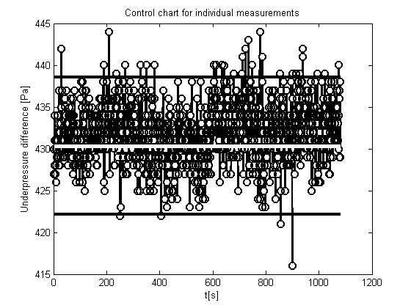
Fig. 2- Control chart for individual measurements in typical mode of block B2

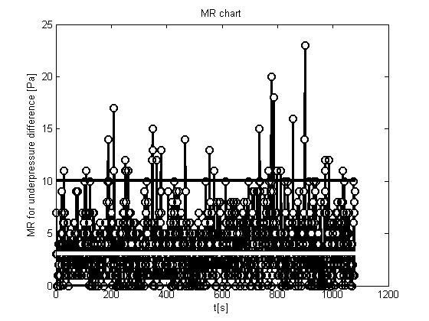
Fig. 3- MR chart for in typical mode of block B2

On figure 2 and figure 3 we can see that in typical mode of block B2 almost all points are between control lines and we can conclude that our process is under statistical control.
On figure 4 and figure 5 we can see that after 1500th sample is one point far from control line, which means that fault is detected and that is time moment when block outage began. After that sample, we can see distancing of points from central line which means that process is out of statistical control.

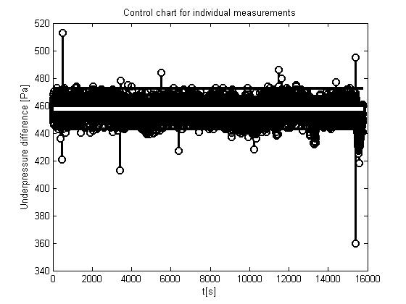
Fig. 4- Control chart for individual measurements during the block outage
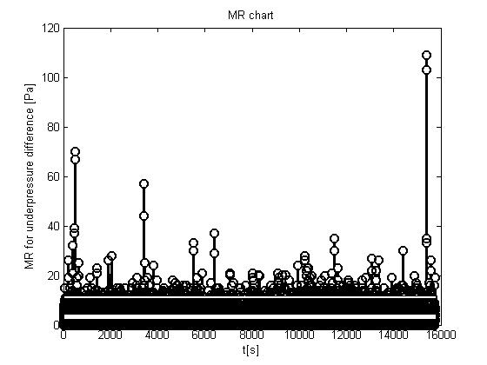
Fig. 5- MR chart during the block outage

Conclusion

We can conclude that control charts are very useful tool for process monitoring and control. However, in practice we have to take care of a few things. Independence of the observations is the most important assumption used during control chart design. Conventional control charts do not work well if the quality characteristics exhibit even low levels of correlation over time. Specifically, these control charts will give misleading results in the form of too many false alarms if the data are positively correlated. This point has been made by numerous authors [7, 8]. There are many techniques that can be found in literature for solving this problem [2]. Almost all approaches are based on analytical techniques. These approaches have proved useful in dealing with correlated data by direct modeling the correlative structure with an appropriate time series model (AR, ARIMA) and using that model to remove autocorrelation from the data and then applying control charts on residuals [9]. Also, there is approach that is not based on the model, e.g a model-free approach [10] and it is applied in this paper. Runger and Willemain [10] proposed a control chart based on unweighted batch means for monitoring autocorrelated process data. The unweighted batch means chart breaks successive groups of sequential observations into batches, with equal weights assigned to every point in the batch. The important implication of this method is that although one has to determine an appropriate batch size b, it is not necessary to construct an ARIMA model of the data.
The second problem that we must take care of during the control chart designing is nonnormality of data from the old system of measurement. General model of control chart assume normal distribution of data and therefore if we choose three-sigma control limits then it is assumed that 99.7% of points will fall inside the control limits while the system is in statistical control. Very often this assumption is not valid, so control charts that do not assume normality of data are developed. They can be found in literature as distribution-free or nonparamteric control charts [11]. A key advantage of distribution-free charts is that the user does not need to assume any particular distribution (such as the normal distribution) for the underlying process and the in-control probability calculations and associated conclusions remain valid for any continuous distribution. This distribution robustness could be an advantage, particularly, in start-up situations where we usually do not have knowledge of the underlying distribution.
Also, there is a big problem with control chart designing of dynamic-behavior processes. A possible solution for this problem would be the making of adaptive control limits that follow system dynamics in the sense that big variation from central line which is consequence of system dynamics, not system fault, is treated as the nominal operation mode. In the literature one can find some solutions for this problem [12], but there is a lot of space for new ideas.

Literature

1. Shewhart W. Economic Control of Quality of Manufactured Product. D. Van Nostrand Co. 1931.
2. Montgomery D. Introduction to Statistical Quality Control. Fifth Edition. New York. John Wiley & Sons 2005.
3. Hotelling H. Multivariate quality control Techniques of Statistical Analysis. 1947. pp. 111-184.
4. Lowry C, Woodall W, Champ C, Rigdon S. A multivariate exponentially weighted moving average control chart. Technometrics. 1992. 34(1). pp. 46-53.
5. Pignatiello J, Runger G. Comparison of multivariate cusum charts Journal of Quality Technology 1990. 22(3). pp. 173-186.
6. Lowry C, Montgomery D. A review of multivariate control charts. IIE transactions. 1995. Vol. 27(6). pp. 800-810.
7. Montgomery D, Mastrangelo C. Some Statistical Process Control Methods for Autocorrelated Data (with Discussion). Journal of Quality Technology. 1991. 23. pp. 179-204.
8. Alwan L. Effects of Autocorrelation on Control Charts Communications in Statistics-Theory and Methods. Vol. 21 (4). 1992. pp. 1025-1049.
9. Montgomery D, Johnson L, Gardiner J. Forecasting and Time Series Analysis. 2nd ed. McGraw-Hill. New York. 1990.
10. Runger G, Willemain T. Batch Means Control Charts for Autocorrelated Data. IIE Transactions. Vol. 28 (6). 1996. pp. 483-487.
11. Chakraborti S, van der Laan P, van der Wiel M. A Distribution-Free Control Charts. Applied Statistics. 53 Part 3. 2004. pp. 443-462.
12. Haridy S, Wu Z. Univariate and Multivariate Control Charts for Monitoring Dynamic-Behavior Processes: a Case Study. Journal of Industrial Engineering and Management. Vol.2. No.3. 2009. pp. 464-49.

