Use of blogs in e-learning course

Djenic S.¹, Miletic A.¹, Mitic J.¹, Petkovic V.¹, Vasiljevic V.¹

¹School of Electrical Engineering and Computer Engineering of Applied Science, Belgrade, Serbia

Blogs, like the most of Web 2.0 tools enable instructors to interact with students in various innovative ways. They can be used in various ways in online education. Blogs consist of list of entries in reverse chronological order published on the Web. In this paper we present the use of open source programming tool Mahara for creating and editing students' blogs. We primarily used it for evaluation of students' work. It also improved their experience of learning in online environment, enhanced collaboration and improved communication. The purpose of this paper is to present our experiences and results.
Introduction
Today's generation of students are so called digital natives. Children that grew up in a world surrounded with technology, Internet, smart phones, mp3 players, video games etc. They have not just changed incrementally from students of the past, nor simply changed their slang, clothes, body adornments, or styles, as has happened between generations previously.
A really big discontinuity has taken place. One might even call it a “singularity” – an event which changes things so fundamentally that there is absolutely no going back. This so-called “singularity” is the arrival and rapid dissemination of digital technology in the last decades of the 20th century [1].
If educators want to reach out to their students, they need to accept this fact, and find new ways of presentation and explanation of their subject matter. One way in doing so is by using technologies that their students use in everyday life. Students can use blogs for presenting their work, they can tweet questions in class, record videos and put them on YouTube, watch videos on YouTube etc. In this paper we will present an implementation of one o these activities in the course Introduction to Information Technologies. Students were using blogs for presenting their seminal paper in this class. In the first part of this paper Web 2.0 technologies and social networks are presented. In the second part of this paper, Mahara a tool for e portfolios is presented and its use in our course. Also the connection of Moodle and Mahara is explained. In the third part of this paper results of use of Mahara are presented. In the fourth section the results are explained and conclusions are given.
Web 2.0 and social networks
Web 2.0 is a version of the Web whose main characteristic is active user participation in the creation of content on the Web site. This users’ contribution is reflected in the creation and editing of content, assessment, adding comments and tags. Other users now have new information that content creators are considered to be of significance.
The term Web 2.0 was first used by Tim O'Reilly, Founder and CEO O'Reilly Media Inc. After O'Reilly Media Web 2.0 conference 2004th started the rapid spread its use.
The first Google index in 1998 already had 26 million pages, and by 2000 the Google index reached the one billion mark. By 2008 there were 1 trillion unique URLs on the web at once [2]. Also the majority of Web 2.0 websites have made their data open to the public by using Web API-s and RSS feeds (first was Google Maps). That is why the Web today is little closer to the Web that its creator Tim Berners-Lee envisioned, the Web of open and interconnected data [3].
Social networks are an open place where people meet, collaborate, and share information.
The fact that people are the center of attention when it comes to social networks has led to The Times 2006th person of the year to be ordinary people. That year, in addition to many important things that have happened, the focus of the story is found in the community of people and cooperation between them in the scale that has not previously existed. The World Wide Web has enabled millions of people to put video content on YouTube, or create online metropolis MySpace. New Web technologies enable the collection of various contents raises a number of people, who thus become more important [4].
Collective Intelligence, a phenomenon referred to as "wisdom of crowds" is one of the main characteristics of social networks. This term implies the participation of a large number of people, usually of different backgrounds, habits and ways of thinking, the process of creating digital content. In this way generally leads to better answer questions and test results, as opposed to the process where the views of the individuals considered separately [5].
An example of collective intelligence is folksonomy, collaborative classification of content. This classification is achieved by creating and managing tags.
Creating tags or "tagging" is a very popular way of classifying content on Web 2.0 sites. Tag is a keyword whose role is labeling items or categories. The user is allowed to join any keyword to identify the contents as well as link to social bookmarking case, or a song, video or photos in the case of sites for the exchange of digital content. The main feature is that the tags can be shared, used in searches or recommend based on selection of other users of the same content.
On the social networking sites users are responsible for adding and updating information that are available to everyone. These virtual communities allow its users to share opinions, discuss, collaborate and discuss topics related to their common interests. User generated content and sharing information sent are the main driving force in the formation and maintenance of on-line communities [6].
User generated content has changed the way of the Internet, and instead of the one-way transmission of media content from a number of companies, now its created by the user and exchanged between them [7].
Blogs and Mahara environment
A blog represents very useful way to allow any user on the Internet to present its personal and business data and to follow their performance and progress in various stages of study or work.
A blog is a kind of catalog or journal, because it usually keeps:
- author profile (personal information),
- information about education,
- business activities and current interests,
- opinions about certain topics,
- short reports on work done in stages ...
Blog may contain text, attachments to files, link to web pages, video, audio and multimedia content. It can be used very simply to create e-portfolio (electronic portfolio / digital portfolio).
Mahara is free, open-source ePortfolio system, first established in mid 2006. It started as a project funded by New Zealand's Tertiary Education Commission's eCDF (e-learning Collaborative Development Fund) involving several New Zealand's universities. Mahara is user oriented web application, and as a learner center, it's a form of Personal Learning Environment (PLE) [8].
Mahara can be connected with a custom Learning Management System (LMS) such as Moodle. In this paper work was used Mahara version 1.4.0 and it has been integrated along with Moodle server, version 2.2.8.
Moodle server: http://lectio.viser.edu.rs/moodle/
Mahara server: http:// wip2.viser.edu.rs/mahara/
Mahara is a stand-alone system that can be integrated into a wider virtual learning framework. Mahara’s architecture is inspired by the modular, extensible architecture of Moodle. The Mahara team has also been heavily involved in the Moodle community, with recent work mostly focused on Moodle Networks. Similarly, Mahara systems can be networked together as well having single sign-on from Moodle 1.9 upwards. In a sense, we see Mahara as a ‘sister’ application although the two systems are not required to go together [8].
In Mahara user controls which items and information are visible to other users within portfolio. All information within someone's portfolio is called View. Owner of ePortfolio can control what is visible for different user groups.
Mahara has comprehensive blogging tool. Blogs and blog postings may be managed and published to ePortfolio, using the WYSIWYG editor. This text editor allows user to: attach files to posts, embedding images into posts and preparing drafts for later use and publishing.
Social networking is one of the features that are also provided by Mahara. Users can add friends into their list of contacts, send requests and messages.
In addition Mahara is designed to:
- be load balanced across several web servers
- have a share file data from a centralized file server
- have a separate database server.
Mahara and Moodle
Mahara has been designed as a web application with a plug-in architecture. This means it is possible to scale the application up by separating hardware for search, database, file storage, and web servers. If there is LMS platform with existing users' database, you can allow to registers LMS students easy access to Mahara platform using LDAP (Lightweight Directory Access Protocol) server. If you want your student to be able to authenticate from either Moodle or Mahara it is possible with a LDAP server with Mahara and Moodle pointing to it, so they will have to log in on each platform but with one account.
Creating and editing blogs in Mahara
To start using Mahara user need to be logged on built server. In our case server is located at following link: https://wip2.viser.edu.rs/mahara/. To access the server user need to be authenticated on common LDAP server which is used by Moodle and Mahara.
In order to create blog in Mahara you need to choose Content option from main menu, and after that Journal tab which is located under the main menu. Next step is to create New Entry and to enter blog title, context of the blog and to confirm all modifications. Entries are good way to organize blog context into separate units. Every unit consists of title, body which may contain text, pictures, links, other multimedia data and attachments. After creating blog, owner has to publish it into his e-portfolio profile in order to make blog visible to other users [9].

Fig.1. Creating new journal entry in Mahara

Fig.2. Publishing journal entry on profile page
Using blogs in e-learning course
In order encourage students to apply new information and communication technologies in their learning and work the survey was conducted where students were given to write their term papers in the form of a blog instead of classic Word text and Power Point presentations. This survey was taken on course Information technology including students on first semester who were attended traditional and distance learning classes on study program New Computing Technologies. Population of students who were involved, included group of 20 distance learning and traditional classes group of 148 participants on study programs New Computing Technologies and Audio and Video Technologies.
Students were given detailed instruction for blog structure including following items:
- 1st title: Short introduction "About me",
- 2nd title: Themes and software tools in the field of information technology that interested me the most
- 3rd title: Paper title and introduction with technical requirements for writing.

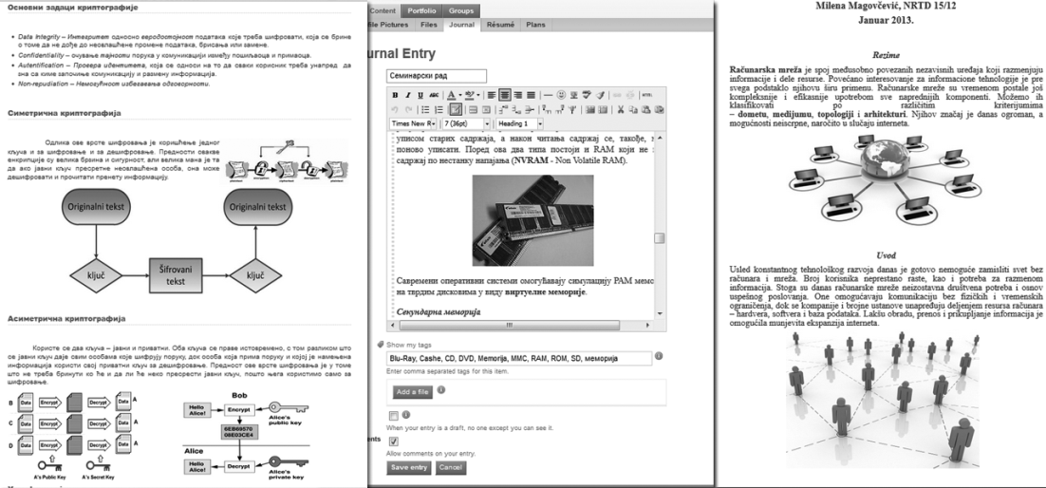

Fig.3. Examples of students' blogs in Mahara environment

After blogs submissions students were asked in final discussion to give their answers and opinions on following question: "Do you think that today's students are proficient in the use of technology in everyday life, means that skilled in the use of technology in learning. Do you use modern technology in learning and in what way?"
Some of the answers given by the students are:
- "With the fact that we grew up in the era of the Internet, the digital era, we do not just think in other way, but we have different habits. From communication with people who are down to correspondence across different social networks, SMS messages, e-mails, and many other services, we primarily have a different insight into the world and access to information via the Internet."
- "Many also use Internet technology in the wrong way. Children should learn to use the technology in the right way, to learn about technologies from teachers and parents, not only from their peers, to review critical information from the Internet, to use new technologies for learning and work, not only to communicate with friends and for games. In order to enable all of this could adequately teach students, it is anticipated that in the future and their responsibility in undertaking this work will be the integration of new technologies in the teaching process."
Results show that today's students are familiar with using technologies in every day's life and also in most cases prefer also to learn using Internet and mobile devices. Concept of blogging is easy way to present students' works in a form of e-portfolio not only to teachers but also to other peers who can be included in evaluation and grading each other's works.
Conclusions
In this paper we presented the use of blogging and ePortfolio system Mahara in high education. Students used these technologies to present their seminal papers in the course Information Technologies. Students were given different subjects and presented their work to their fellow colleagues and teachers using Mahara environment. Since they were familiar with this kind of technology they didn't need extra instructions from teachers to use it, and they liked the fact that a certain kind of freedom in presentation was given to them. They also showed enthusiasm and were into this kind of activity in course. So, it is a good idea to use technologies from the world outside of school to bring closer course materials to students.
Literature
1. M. Prensky, "Digital Natives, Digital Immigrants," On the Horizon, vol. 9, 2001.
2. "We knew the web was big...," 25 July 2008. [Online]. Available: http://googleblog.blogspot.com/2008/07/we-knew-web-was-big.html. [Accessed 11 July 2013].
3. T. Berners-Lee, J. Hendle and O. Lassila, "The Semantic Web," Scientific American, 2001.
4. L. Grossman, "Time's Person of the Year: You," 26 December 2006. [Online]. Available: http://www.time.com/time/magazine/article/0,9171,1569514,00.html.
5. J. Surowiecki, The Wisdom of Crowds: Why the Many Are Smarter Than the Few and How Collective Wisdom Shapes Business, Economies, Societies and Nations, New York: Anchor Books, 2004..
6.J. Bernal, Web 2.0 and Social Networking for the Enterprise: guidelines and examples for implementation and management within your organization, 2009, IBM Press.
7. K. Seongwoon, L. Inseong, L. Kih and J. Seungk, "Mobile Web 2.0 With Multi-Display Buttons," Communications of the ACM, 2010.
8. "https://mahara.org/," [Online].
9. S. Djenic, A. Miletic, M. Radivojevic and M. Karadzic, Information technologies - manual, Belgrade: School of Electrical Engineering and Computer Science Applied Studies, 2012.
10. "API Dashboard," [Online]. Available: http://www.programmableweb.com/apis.

