SOME SIMULATION METHODS FOR RECEIVE SATELLITE ANTENNA INSTALLING ANGLES EVALUATION.
H.Z.Stefanovic¹, A.M.Savic¹, S.D.Veljkovic², D.N.Milic²
¹High School of Electrical Engineering and Computer Science, Belgrade, Serbia
²Faculty of Electronic Engineering, Nis, Serbia

This paper presents some analytical performance criterion characteristics of receive satellite antenna dishes, also including the numerical calculation of the angles necessary for their installation. The influence of antenna dish size, carrier signal frequency and antenna efficiency on satellite link performance measures is also considered, while the installing parameters are calculated for different satellites which can be physically visible from selected user location.

Introduction
The design of an antenna system plays a powerful role in improving the performance and reducing the required transmit power for wireless link layer designs [1]. In satellite communications, receive antenna system properties (including reflectors, feeds, mounts, servo controls, converters, modems and monitor and control software) are very important [2] because satellite orbits are very distant from the Earth. The receive satellite antenna collects weak signal from satellite and removes noise as far as possible, providing higher receiving signal quality. The design of an antenna system [2, 3] involves deciding how much antenna gain is needed and specifying amplifiers and receivers for a specific signal-to-noise ratio (SNR). For a given power density, the antenna gain determines the power into the receiver. The choice of the antenna gain for acceptable performance is very important because small values of antenna gain implies the noisy signal, but if the antenna gain is too large, the signal will be distorted due to saturation of the receiver.
Satellite systems provide voice, data and broadcast services with widespread, often global, coverage to high-mobility users as well as to fixed sites. Satellite communication networks have the same basic architecture as cellular systems [3-5], except that the cell base-stations are satellites orbiting the Earth. The satellite orbits are characterized [6] by their distance from the Earth: low-earth orbits (LEO) at 500-2000 km, medium-earth orbits (MEO) at 10.000 km and geosynchronous orbits (GEO) at 36.000 km. Geosynchronous satellites have a large coverage area that is stationary over time, since the Earth and satellite orbits are synchronous [7], while the satellites with lower orbits have smaller coverage areas changing over time, so satellite handoff is needed for stationary users or fixed point service.
The most well-known reflector antenna used in satellite communications is the parabolic reflector antenna commonly known as a satellite dish antenna. Parabolic reflectors are characterized with a very high gain (30-40 dB) and low cross-polarization [8]. The smaller dish antennas typically operate between 2 and 28 GHz, while the large dishes can operate in lower frequency bands.
Parabolic dish antenna consists of a feed antenna (which is usually a horn antenna with a circular aperture) pointed towards a parabolic reflector [9]. The dish is at latest several wavelengths in diameter, but the diameter can be the order of hundred wavelengths for very high gain dishes (gain over 50 dB). The distance between the feed antenna and the reflector is typically several wavelengths as well. An offset-feed dish antenna is a type of parabolic antenna, usually used in satellite communications [10]. The purpose of offset antenna dish design is to move the feed antenna and its supports out of the incoming radio-waves path.
Current research on antennas focuses on making antennas smaller, particularly in communications for personal wireless communication devices [8]. A lot of work is performed on numerical modeling of antennas [8-11], so their properties can be predicted before they are built or tested. Future trends include developing even higher gain satellite antennas with greater efficiencies in terms of frequency reuse or higher satellite systems capacity.
Since the performance of modern satellite communication systems can be significantly improved by the employment of high quality directive antennas, this paper discusses the dependency of antenna gain and directionality on different parameters, also including some practical implementation methods important for installing the receive satellite antenna dish.

Receive satellite dish antenna properties
The parabolic shape of a dish antenna is designed to capture incoming satellite signal and focus it to a central focal point, where it is concentrated and fed to a feedhorn [1]. The feedhorn is a waveguide shaped in the form a cylindrical structure usually, and positioned at or near the focal point of parabolic dish antenna. The waveguide directs the incoming signal to a low-noise-block-down-converter (LNB) which is a transducer that converts electromagnetic waves into electric signal and shifts the frequency into the lower band. In most home use satellite dishes, the feedhorn and the LNB are integrated into one device. The gain or received signal power is dependent on the perfection of the dish shaping and the waveguide matching.
The gain of parabolic antenna is modeled by the following equation [1]:
(1)
where λ =c/f presents a carrier signal wavelength, while effective antenna area S_{eff} depending on antenna efficiency η and antenna diameter D is defined as:
(2)
Substituting (2) into (1) yields:
(3)
Antenna efficiency typically takes values from 0.5 to 0.75.
A parabolic dish antenna can provide very high gain at microwave frequencies, but only with very sharp beamwidths. To achieve an optimum gain a careful attention to detail is required, including checking the parabolic surface accuracy wit a template, matching the feedhorn to the f/D ratio of the dish and locating the phase center of the feedhorn at the focus. The higher values of gain, describing the amount of energy radiated by the main lobe versus the amount energy radiated by an isotropic antenna, implies the more focused radio signal and the narrower beamwidth.
The half-power (-3 dB) beamwidth 2θ_{3dB}, which is another important dish property, presents an angle (in degrees) between the half-power point of the main lobe. This angle, presenting the width of the main lobe at -3 dB, can be, for the value η=0.55, calculated as:
(4)
The parabolic antenna gain dependency on angle of boresight θ is given with [8]:
(5)
where J₁( ) presents first order Bessel function [12] with argument x defined as [8]:
(6)
The parabolic antenna radiation pattern, describing its sensitivity as a function of angle from boresight axis, is presented in Fig.1. and Fig.2, in the case when carrier frequency and antenna diameter are varied, respectively.

Fig. 1. The gain of parabolic antenna versus angle from boresight axis, for different values of carrier signal frequency

Fig. 2. The gain of parabolic antenna versus angle from boresight axis, for different values of antenna diameter

Comparing the results from Fig.1. and Fig.2. it can be concluded that antenna radiation pattern heavily depends on carrier signal frequency and antenna dish size.
In satellite communications, the circular antenna aperture is often used, but sometimes the rectangular antenna apertures are also applied. Fig.4. and Fig.5. present the three-dimensional (3D) pattern of field strength for different rectangular and circle aperture dimensions, as a function of the independent variables v_{x} and v_{y}. The quantities v_{x} and v_{y}, for rectangular aperture dimensions a and b are defined as:
(7)
As the polar angles vary over 0<θ>90º and 0<φ<360º, the quantities v_{x} and v_{y} vary over limits – a/λ < v_{x} <a/λ and – b/λ < v_{y}< b/λ, for rectangular aperture dimensions a and b.
Fig.4. shows the 3D pattern of field strength as a function of the independent variables v_{x} and v_{y} defined by (7). The separability of the pattern in v_{x}-v_{y} plane is evident, as it is illustrated in Fig.4.

Fig. 3. The 3D pattern of field strength for rectangular aperture dimensions a=8λ and b=4λ
For the circular aperture with radius a, the quantities v_{x} and v_{y} are defined as:
(8)
while the 3D pattern of field strength for circular aperture, as a function of independent variables v_{x} and v_{y} defined by (8) is presented in Fig.5.

Fig. 4. The 3D pattern of field strength for circular aperture radius a=3λ
The visible region is the circle, in v_{x}-v_{y} plane, as it is illustrated in Fig.5.
Software tools for satellite antenna dish installation
The satellite dish installation includes adjusting the orientation (elevation – vertical angle as well as azimuth – horizontal angle). The program Satellite Antenna Alignment is used to calculate the angles necessary for installing satellite dishes. The geographical coordinates of the location where the dish will be installed are entered, as it is presented in Fig.5 for user position in Belgrade. The calculation of azimuth and elevation for choice ASTRA 1C satellite is given, but it could be done for all satellites physically visible from this location. The azimuth presents the direction to the satellite in degrees from the clockwise direction to the North, while the elevation is an angle (in degrees) between the direction of the signal from the satellite and a tangential plane to the Earth surface in the location.
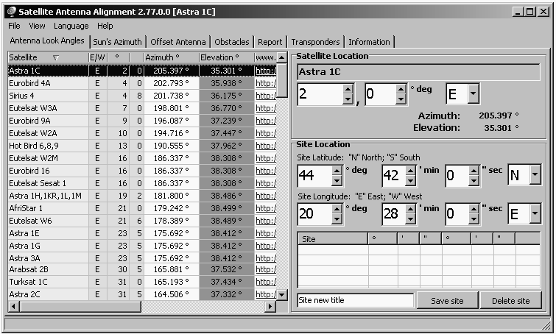

Fig. 5. Calculation of the azimuth and elevation angle using Satellite Antenna Alignment from user location in Belgarde and choice ASTRA 1C satellite
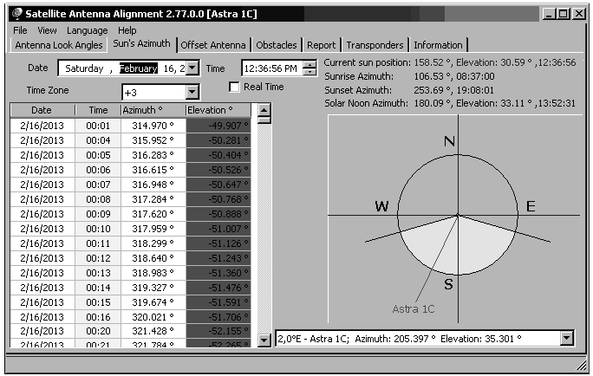

Fig. 6. Calculation of the Sun’s azimuth using Satellite Antenna Alignment from user location in Belgrade
The calculation of the Sun’s azimuth is given in Fig.6, for the location coordinates specified as in Fig.5. Both the azimuth and the elevation angles are calculated for the Sun at the current moment of time. After finding the Sun’s azimuth (for the current day, or another day on which the dish instalation is planned) that is the most close to the azimuth of the chosen satellite (ASTRA 1C), user can turn the dish to the Sun at the specified moment of time, because the Sun’s azimuth coincides with the azimuth of the satellite at this moment.
An interactive program Satellite Antenna Alignment is used for installing an offset-feed satellite dish antenna, which also has the feed at the focus of the parabola, but the reflector forms only a section of the parabola. The feed of the offset-feed antenna is not on the boresight, resulting that none of the radiated beam is blocked by the feed horn. After entering the size of dish (heigh and width), the exact elevation for the dish is calculated, as it is presented in Fig.7. The calculation illustrated in Fig.7 is done for ofsset-feed receive satellite dish width 0.8 m and heigh 1 m, while the estimated angle values are given in degrees.
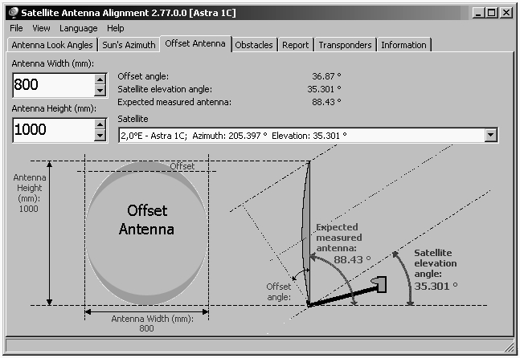

Fig. 7. Calculation of the angles necessary for installing satellite offset dish (heigh 1 m and width 0.8 m) using Satellite Antenna Alignment from user location in Belgrade
This program allows users to evaluate the dish installing angles quite precisely, also including the possibility to take into account a lot of additional factors which are important when a satellite dish is installed. These factors include various obstacles (buildings, trees), the landscape, the altitude, transponder orientation, polarazation, etc.
There are many applications that can be used to show or predict the satellites position at any given moment, from the user location, which is very important for satellite selection. Satellite tracker Orbitron or SatExplorer are usually used interactive applications, including the possibility for selected satellites to be tracked all in the same time. The orbit informations and database of satellite frequencies are also given, as it is illustrated in Fig.8. Orbitron satellite tracker includes many additional program functions and settings, like time synchronization when Orbitron starts, setting Acquisition of Signal (AoS) elevation limit, radar viewpoint with different rotations, including full interactive mode for viewpoint, as it is illustrated in Fig.8. Real-time mode and simulation mode are available, including extended map and interface settings, with AoS notification which enables every satellite to be automatically marked as active when this option is checked.
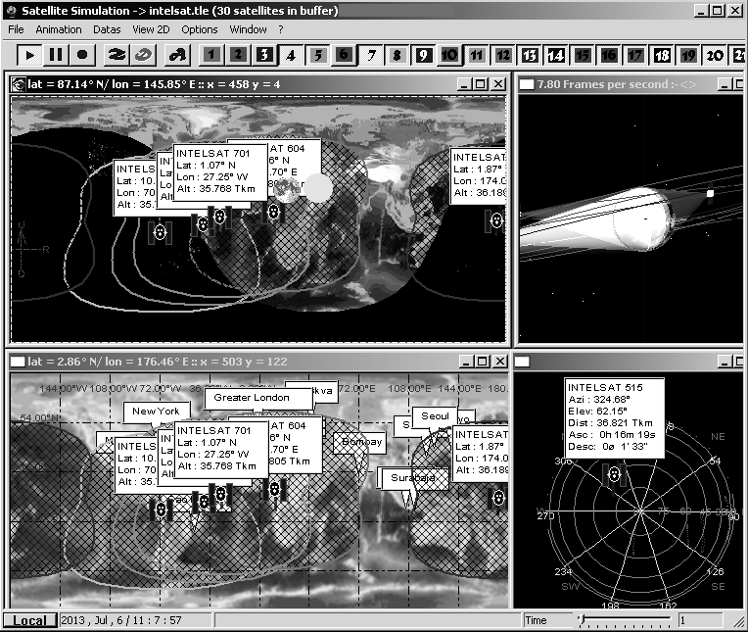

Fig. 8. Satellite tracking system showing the satellite positions at any specified moment

Conclusion
Since high quality and cost-effective receive satellite antennas are very popular products, designing the sophisticated technological antenna system parts is constantly being developed and introduced, also including the practical implementation optimization. This paper presents some software tools for numerical modeling of receive satellite antenna installing parameters, while the effect of different parameters on antenna gain and directionality is also analyzed.

Literature
- Pratt T, Bostian C, Allnut J. Satellite Communications. 2nd ed., John Wiley&Sons Inc., 2003.
- Tranter W, Shanmugan K, Rappaport T, Kosbar K. Communication Systems Simulation with Wireless Applications. Prentice Hall, 2004.
- Proakis J. Digital Communications. 3rd ed., McGraw-Hill, 1999.
- Lee W.Y.C. Mobile Cellular Communications. McGraw-Hill Book Co., New York, 1989.
- Stuber G.L. Principles of Mobile Communications. 2nd ed., Kluwer Academic Publishers, 2001.
- Roddy D. Satellite Communications. 4th ed., McGraw-Hill, 2006.
- Elbert B. Introduction to Satellite Communications. 3rd ed., Artec House, 2008.
- Dybdal B. Communication Satellite Antennas: System Architecture, Technology, and Evaluation. McGraw-Hill, 2009.
- Evans B.G. Satellite Communication Systems. 3rd ed., The Institution of Engineering and Technology, UK, 2008.
- Kolawole M. Satellite Communication Engineering. Marcel Dekker Inc., 2002.
- Stefanovic H, Savic A, Veljkovic S, Milic D. Numerical modeling of receive satellite antenna installing parameters. International Journal of Science, Innovation and New Technology–IJSINT, Vol.1. No.6. 2013. P.19-25.
- Abramowitz M, Stegun I. Handbook of Mathematical Functions. NBS, Washington, 1972.

