The Global Fractal Method, Fractal Paradigm and the Fractional Derivatives Method in Fundamental Radar Problems and Designing of Revolutionary Radio Signals Detectors

A.A. Potapov

V.A. Kotel’nikov Institute of Radio Engineering and Electronics RAS,
Mokhovaya str., 11/7, 125009 Moscow, Russian Federation
email: potapov@cplire.ru; www.potapov-fractal.com

Abstract: The main methodological problems arising during the comprehensive use of the global fractal method proposed by the author and of the existing method of fractal operators in radar are considered in the paper. The topicality of this work is first of all based on a critical need in understanding of fractality and randomness as a unified integral process of forming the fractal paradigm in a wide spectrum of natural sciences, technical sciences and humanities. The paper suggests a general view on fundamental problems mentioned in the title from the synergetic point of view of open non-markovian micro- and macrosystems to a reader.

1. Introduction
The article reflects main conceptions which are being developed by the Russian scientific school of fractals methods and fractional operators (the founder and leader is professor A.A.Potapov). There are three main lines in the basis of modern fractal researches: development of theoretical foundations of fractal approach, building of an appropriate research apparat and application of fractal conceptions and frequent methods. All the three lines are considered in this paper. The topicality of this work is first of all based on a critical need in understanding of fractality and randomness as a unified integral process of forming the fractal paradigm in a wide spectrum of natural sciences, technical sciences and humanities, i.e. “the fractal natural science” [1 - 5].
The work purpose is to attract attention to methodological problems arising during the comprehensive use of the global fractal method created by myself and the existing method of fractional integro-derivatives in radar.
Word “method” in the paper title means that the work matter is not just the fractal theory and fractional-differential calculus as such but it is also its physical and radio engineering applications that essentially makes up the main purpose in a wide area of scientific concerns of the author. Particularly, our world priorities in constructive methods of fractal detection of superweak radio signals, methods of fractal processing of multidimensional signals, synthesis of fractal radio systems and fractal radio elements are obvious and do not require any explanations. Everything is simple from scratch: it was not so before my works and it’s become so after my works. I guess that four examples above (I can give you much more) is enough.

2. Creation of Global Fractal Method and Fractal Paradigm in Russia
The work is based on fundamental theoretical and experimental results obtained over more than 30 years of the author’s and his pupils work on the systematic implementation of fractals, operators of fractional integro-differentiation and scaling effects into the radar, radio physics and also into a wide spectrum of adjoining academic and technical areas in V.A. Kotel’nikov Institute of Radio Engineering and Electronics RAS – Fig. 1 [1 - 15]. Substantiation of my considerations is included in the earlier published monographs (see for example [1 - 15], its references and the author’s web page www.potapov-fractal.com).

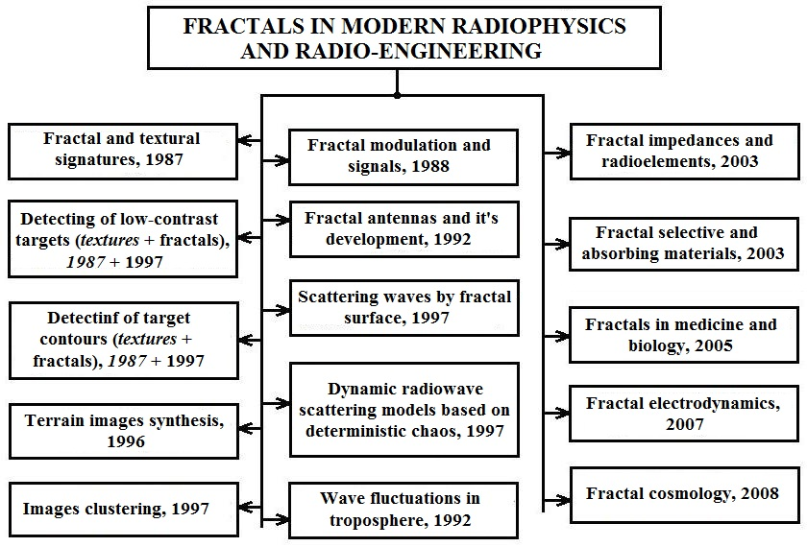

Figure 1. Sketch of author's development of new information technologies based on fractals, fractional operators and scaling effects

The fractal conceptions developed by B. Mandelbrot (20.11.1924 – 14.10.2010) approximately forty years ago become a connecting link among mathematicians, physicists, chemists, engineers, geologist, bio-physicists… Extension of these conceptions to inclusion of generalized statistics (which does not follow the central limit theorem) and memory effects (hereditarity) which break the Markovian nature of the first stages of random processes investigation created a very rich tool which is rather comprehensive to describe the features of complex systems of the World and engineering which have a probabilistic nature.
The fractional integro-derivatives method works perfectly. An example: breakthrough in the area of nonintegral number of iterative operations in integro-differential calculus (fractional degrees of differentiation and integration operators fractional operators) [1 - 16]. This breakthrough is impressive: the family of differential equations is enriched; empty intervals between equations of integral orders are tightly filled with equations of nonintegral real orders; the continuous transitions between parabolic, hyperbolic and elliptic types of partial differential of equations become probable. Presence of a fractional time derivative in equations is interpreted as reflection of memory/hereditarity or non-Markov behavior of a stochastic process. Fractional derivatives on space variables stand for self-similar irregularity of a fractal structure or fractal medium in which the process develops. Physically, operators of fractional integration act the part of peculiar “filters” distinguishing only those components which are localized on the fractal (fractional) sets of a process under examination.
The global fractal method was finally proposed by the author in the full form in 2006 after 30 years of development. Roughly speaking, it can be said that fractals were a thin amalgam on the massive frame of science of the end of twentieth century. In the current situation attempts to reduce the importance of fractals and to rely on the classical knowledge only have come to an intellectual grief. The author relies on the own definition of a fractal in his works. (It was approved by B. Mandelbrot during our personal meeting in New York in 2005. Currently everyone uses it…).
In fractal researches I always rely on my three global theses [1 - 5]: 1. – Processing of the information distorted by non-Gaussian noise in the fractional measure space using the scaling and the stable non-Gaussian probabilistic distributions (1981). 2.- Applying of continuous nondifferentiable functions (1990). 3. – Fractal radio systems (2005) – Fig. 2.
In future, logical unification of the mentioned triad of problems into a general “fractal analysis and synthesis” makes for us a foundation of fractal method (2006) and united global idea of fractal nature science and fractal paradigm (2011), proposed by the author.

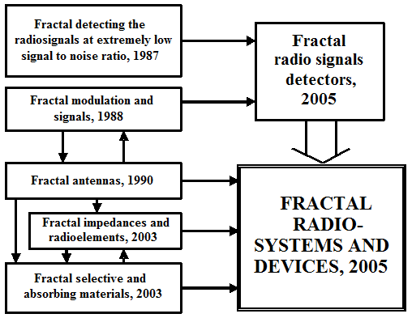

Figure 2. Author’s conception of fractal radio systems and devices

In 2011 – 2012 the author’s proposed a new paradigm (fractal) in understanding the natural science. What is indeed the author’s paradigm based on? Firstly, on the fractals; secondly, on the fractional operators; thirdly, on the scaling or selfsimilarity.

3. Perspective Fractal Researches in Fundamental Radar Problems
The paper reflects the progress reached in development of general conceptions of the fractality over this thirty years period. Now my ideas and methods expand to almost all knowledge areas. Lower, we, basing on our works (see the author’s web page – http://www.potapov-fractal.com) will try to take the common vision of most perspective and fundamental directions of “fractal” researches:
- -Research of possibility of texture (spatial and spectral) fractal and entropy attributes for radiolocation detecting problems.
- -Synthesis of new models of radiolocation signals scattering by land cover based on theory of deterministic chaos, strange attractors and fractal probabilistic distributions – stable distributions.
- -Research of wave phenomena (propagation and scattering waves, diffusion processes) at fractal anisotropic environments based on fractional integration-differentiation. Further development in fractal electrodynamics.
- -Model synthesis of radiolocation and telecommunication systems channels, based on spatial fractal generalized correlators and fractal frequency functions of coherency.
- -Research of possibilities of detecting form or contour of targets by using fractal, texture and entropy attributes. Work with singularities of input functions.
- -Research of potential possibilities and limitations of fractal methods of radiolocation and communication signal processing, including fractal modulation and demodulation, fractal coding and compressing of information, fractal image synthesis and fractal filters. Transition of fractal radiosystems.
- -Research of adaptive spatiotemporal signal processing based on fractional dimension and fractional operators.
- -Search and investigation of new combined methods of low-contrast targets classes detecting and identification at intensive non-Gaussian noises.
- -Research of possibilities of creating a new environments for information transferring, multiple ranges fractal absorbing materials, constructing of fractal antennas and fractal frequency-selective surfaces and volumes. Further development of theory and technologies of fractal impedances.
- -Synthesis the new classes of fractals and multi-fractals with generalization of set dimension concept.
- -Investigation the kind or topology of one-dimensional (multidimensional) signal sample for problems, such as artificial intelligence in order to creation of dictionaries of fractal attributes based on fractal primitives, the elements of fractal language with fractal grammar, i. e. investigation of problem named “dimensional sclerosis” of physical signals and signatures. This concepts introduced by author, involves researches of topological peculiarities of each concrete individual sample, but not average realizations, often having other character.
- -Forecast of roughness forming mechanisms and characteristics in order to managing the microrelief geometrical parameters for obtaining specified physical and chemical, and operating properties of devices with modern nonequilibrium technologies of processing it's surface layer. Fractals in nanotechnologies. (At 2008 author proposed the new concept, namely “Scaling in rough fractal layer and nanotechnologies”).
- -Development of fractal non-inertial relativistic radiolocation in curved time-space of connected structures, i. e. fractal geometry of time-space of determined structures. (Presently, in USA this fundamental scientific direction been called as “Fractal Cosmology”. Two of my large works with co-authors there are in list of publications (arXiv: Cornell University, USA) on this direction. - [See our works: J. Foukzon, S.A. Podosenov, A.A. Potapov, “Relativistic length expansion in general accelerated system revisited,” http://arxiv.org/abs/0910.2298v1.-arXiv: 0910.2298, (General Physics), 13 October 2009, Cornell University, USA, 11 pp.; J. Foukzon, S.A. Podosenov, A.A. Potapov, E. Menkova, “Bimetric theory of gravitational-inertial field in Riemannian and in Finsler-Lagrange approximation,” http://arxiv.org/abs/1007.3290, (General Physics), 9 Oct. 2010, 95 pp.; J. Foukzon, A.A. Potapov, S.A. Podosenov, “Hausdorff-Colombeau measure and axiomatic quantum field theory in spacetime with negative B. Mandelbrot dimensions,” http://arxiv.org/abs/1004.0451, 5 Feb. 2011, 206 pp.; J. Foukzon, A.A. Potapov, S.A. Podosenov, “Exact quasiclassical asymptotics beyond Maslov canonical operator,” http://arxiv.org/abs/1110.0098, 4 Oct. 2011, 162 pp.; J. Foukzon, A.A. Potapov, S.A. Podosenov, E.R. Men’kova, “Detecting fractal dimensions via primordial gravitational wave Aastronomy,” http://www.scribd.com/doc/58496226/Detecting-Fractal-Dimensions-via-Primordial-Gravitational-Wave-Astronomy-Fractal-Cosmology 74 pp.].

4. From Fractal Researches to High Technologies and Practice of the Future Radar
Thorough bibliographic investigations proved our total and absolute priority on all “fractal” directions (Fig.1 and Fig. 2) in USSR and in Russia and also in the world science. I should notice that my ideas about fractals and fractional operators with which I spoke three decades ago have already moved now from a purely speculative stage into a stage of tangible reality and reached its maturity as a powerful analytic tool for describing classical and abnormal stochastic processes. There is a serious confirmation for that:
– At book [17, p. 41] in subsection “Radar systems” of section “Information Technology and Computing Systems” given following text: “Created reference dictionary of fractal attributes of optical and RF images, necessary for realization of essentially new fractal methods of radiolocation information processing and creation highly informative devices for detection and recognition of weak signals in intensive non-Gaussian noise. Established, that for effective solving of radiolocation problems and multi-dimensional signals fractal detectors design, fractional dimension, fractal signatures and cepstrums and, also, texture signatures of area backgrounds has significant importance” (IREE of RAS) - 2007, published at 2008.
– At book [18, p. 24] in subsection “Radar systems. Geoinformational technologies and systems”, section “Nanotechnology and Information Technology” given following text: “For the first time in world practice proposed and experimentally proven constructing principles of fractal adaptive radiosystems and fractal radioelements for modern radio-engineering and radiolocation problems. Operation principle of these systems and elements is based on introduction of radiating and received signals fractional transform in non-integer dimension space, considering it’s scaling effects and non-Gaussian statistics. This achievements allows a new level of real non–Markov’s signals and fields informational structure” (IREE of RAS) - 2009, published at 2010.
– At book [19, p. 199] and book [20, p. 242] in subsection “Radar systems. Geoinformational technologies and systems”, section “Informatics and Information Technology” given following text: “Basing on fractal analysis performed systematic research of fractal antennas electrodynamics properties. Confirmed wideband and multi–range properties of fractal antennas and resonances quantity dependence on fractal iteration number. Shown, that, basing on miniature fractal antennas, possible effective realization of frequency-selective environments and shields, deforming radiolocation target image. Investigated fractal frequency-selective 3D-environments or fractal “sandwiches” (engineered radio-electronic micro- and nanoconstructions)” (IREE of RAS) - 2011, published at 2012.

5. Conclusions
Result: the “fractal” measurement should be introduced into the natural science not as an auxiliary tool but as the fundamental explanatory fact.

References:
- A. A. Potapov, Fractal Method and Fractal Paradigm in Modern Natural Science. Voronezh: Nauchnaya Kniga, 2012. 108 p.
- A. A. Potapov, “Reflections on the Fractal Method, Method of the Fractional Integro-Derivatives, and about the Fractal Paradigm in the Modern Natural Science (from the author’s notebooks)”, RENSIT, 2012, vol. 4, no. 1, pp. 103-142.
- A.A. Potapov, “Application of the Fractal Theory and Scaling Effects during Processing of Low-Contrast Images and Super Weak Signals in the Presence of Intensive Noise”, Abstracts Int. conf. “Zababakhin Scientific Talks”, devoted to E.I. Zababakhin’s 95-th anniversary (16-20 April, 2012, Russia, Snezhinsk, Chelyabinsk region), Snezhinsk, RFNC-VNIITF, 2012, pp. 311-312.
- A.A. Potapov, “Fractals, Scaling and Fractional Operators in Information Processing (Moscow Scientific School of Fractal Methods at Kotel’nikov IREE of RAS, 1981-2011),”in Irreversible Processes in Nature and Technology, V. Gorelik and A. Morozov, Eds. Moscow: Bauman MSTU and Lebedev Physical Institute of RAS, 2012, vol. IV, pp. 5-121.
- A.A. Potapov, “Fractal Method and Fractal Paradigm”, Proc. 7th Int. Conf. “Neural Networks and Artificial Intelligence” (10-12, October, 2012, Belarus), Minsk, BSUIR, 2012, pp. 74-77.
- A.A. Potapov, Fractals in Radio Physics and Radar. Moscow: Logos, 2002. 664 p.
- A.A. Potapov, Fractals in Radio Physics and Radar: Topology of Sample. Moscow: University Library, 2005. 848 p.
- A.A. Potapov, “Fractals and chaos as basis of new challenging technologies in modern radio systems,” in Introduction to Fractals and Chaos, R. M. Crownover. Moscow: Tekhnosfera, 2006, pp. 374-479.
- A.A. Potapov, Yu.V. Gulyaev, S.A. Nikitov, A.A. Pakhomov, and V.A. German, Newest Images Processing Methods, A.A. Potapov, Ed. Moscow: Fizmatlit., 2008. 496 p. [a book - the grant RFBR № 07 - 07 - 07005].
- A.A. Potapov, “Fractal Methods of Investigation the Signal Fluctuations and Dynamic Systems in Fractional Dimension Space,” in Fluctuations and Noises in Complex Systems of Living and Inanimate Nature. Kazan: The Ministry of Education and Science of the Republic of Tatarstan, 2008, pp. 257-310.
- A.A. Potapov, A. Kh. Gil’mutdinov, and P.A. Ushakov, Fractal Elements and Radio Systems: Physical Aspects, A.A. Potapov, Ed., Library Journal “Nonlinear World”: Scientific series “Fractals. Chaos. Probability”. Moscow: Radiotekhnika, 2009. 200 p.
- A.A. Potapov, “About Fractal Radio Systems, Fractional Operators, Scaling and so Sorth…,” in Fractals and Fractional Operators, Foreword of acad. Yu. V. Gulyaev and corr. member of RAS S.A. Nikitov. Kazan: “Fan”, 2010, pp. 417-472.
- O.V. Lazorenko, A.A. Potapov, and L.F. Chernogor, “Fractal Super Wideband Signals,” in Information Security: Encryption Methods, E.M. Sukharev, Ed. Moscow: Radiotekhnika, 2011, pp. 151-187.
- A.A. Potapov, “Fractals, Scaling and Fractal Operators for Radar Problems: Fractal Radio Systems Designing”, Proc. Int. Radar Symp. (9-11, September, 2009), Hamburg, TUHH and DGON, 2009. P. 667-670.
- A.A. Potapov and V.A. Chernykh, Fractional Calculus of A.V. Letnikov in Physics of Fractals. Saarbrücken: LAMBERT Academic Publishing, 2012. 688 p.
- K.B. Oldham, J. Spanier, The Fractional Calculus. N.Y.: Academic Press, 1974. 234 р.
- Progress Report of Presidium of the Russian Academy of Sciences. Scientific Achievements of the Russian Academy of Sciences in 2007. Moscow: Nauka Publ., 2008. 204 p.
- Progress Report of Presidium of the Russian Academy of Sciences. Scientific Achievements of the Russian Academy of Sciences in 2009. Moscow: Nauka Publ., 2010. 486 p.
- Progress Report of Presidium of the Russian Academy of Sciences. Scientific Achievements of the Russian Academy of Sciences in 2011. Moscow: Nauka Publ., 2012. 620 p.
- Report to Government of Russian Federation. About 2011 Year Results of Realization of the Fundamental Scientific Researches of State Scientific Academies in 2008 - 2012 Years. In three volumes. Moscow: Nauka Publ., 2012. 1015 p.

