THE SOFTWARE DEFECTS FIXING PROBLEM OPTIMIZATION USING TAGUCHI METHOD
Lj. Lazić, I. Djokić¹, S. Milinković²
¹State University of Novi Pazar, Serbia, ² Union University, School of Computing, Belgrade, Serbia
Software defect repair time is an important factor in software development, and estimates of repair times are essential in planning, scheduling, and resource allocation in software projects. Repair time also depends on the experience and skills of the fixer, his or her workload, and other factors. Predicting defect repair time is a difficult problem that has not been researched as intensively as reliability modeling. This work aims to use defect data from previous software development efforts to describe the when-who-how approach for analyzing defect data. The main goal is to gain a better understanding of the quality control process and identify defect fixing problem improvement opportunities using Taguchi’s Design of Experiments method. We used Analysis of Variance (ANOVA) to correlate problem resolution cycle time with three predictors, problem severity, problem complexity and engineer experience to find parametric equation for total software defect cost and resolution time.

Software defect engineering

Even a well-performed software process introduces defects that impact both development and customer systems. No matter how well we plan and shape software development, defects are generated and can escape to the customers. Failure to quickly resolve software problems leads to negative consequences for our customers and increases internal business costs. A quick deterministic method to prioritize problems and implement their solution helps to reduce cycle time and costs [1].
Defects found in the later stages of the software life cycle tend to be harder to repair than those found in earlier stages [3]. Errors encountered by users are sometimes difficult to reproduce. To make matter worse, repairing one problem may introduce other problems into the system. The ability to predict defect repair time would be useful for creating testing plans and schedules, allocating resources and avoiding project overruns [3,4]. Estimated repair times can improve testing management and consequently, the reliability and time-to market of software.
Achieving this goal requires several steps [1]. The first is to determine a model that links problem resolution performance to institutional variables and problem characteristics. Statistical Design of Experiments (DOE) is a tool that provides data requirements for estimating the impacts of these variables on problem resolution. Once data has been gathered the results of statistical analysis can be input into a mathematical optimization model to guide the organization [3].
Our goal was to describe such an analysis. We used defect data published in [1] from previous software development efforts to describe the when-who-how approach for analyzing defect data to gain a better understanding of the quality control process and identify defect fixing problem improvement opportunities using Taguchi’s Design of Experiments method. We used Analysis of Variance (ANOVA) to correlate problem resolution cycle time with three predictors, problem severity, problem complexity and engineer experience to find parametric equation for total software defect resolution time.
There were several benefits to the project:
- Optimal allocation of problems to the engineering staff resulted in savings of time and money.
- A closer relationship between experienced and novice engineers.
- Knowledge of the necessary problem resolution effort provided a baseline for further problem
process improvement.

Defect management is crucial [1-6] for closing the loop between requirements, implementation and verification and validation. Traditional defect tracking management, implemented in a standalone fashion, can no longer address the complexity and pace of change in the modern software development.

Software Metrics for Maintenance
The analogy with the supermarket directs our attention to metrics for the estimation of maintenance effort. The aim is to develop measures and threshold figures to find out when the service effort will exceed the costs of a new development. Often it is not considered that software – like other products or goods – ages within time and that this a preventive planning of maintenance or redevelopment is necessary. There is broad consensus in the metrics community that productivity depends especially on software size and also that there do exist more parameters influencing productivity. The same holds for maintenance effort. The Cocomo-M(aintenance) model and SLIM both use only one parameter related to maintenance, while PRICE-S, SEER-SEM and Capers Jones‘ estimation tool Checkpoint [4] do use several such parameters. The average size of the maintenance tasks in the organisation with the web based environment was four times as large as in the military organisation, but the average effort was only two times as much. Thus the average cost per maintenance task was in the web based environment only half as much (about 115 person hours) as in the military environment (221 person hours). From historical project data reported 1996 about 21 maintenance projects of Management Information Systems (MIS) type with larger functional enhancements. The average effort for this projects was more than 2,200 person hours or 332 person days. The authors could find a statistical (R2 = 0.81) relationship between size and effort. The data were from an organisation which was known to deliver its projects successfully on time, in costs, in functionality and in quality. The organisation had already in the beginning of the 1990‘s reached CMM level 3 with an evidentially strong quantitative management of the KPI (Key Performance Indicators) on level 5.

The Problem Resolution Process

We examined the way that software problems were assigned in the past projects [1]. We found that problem resolution process faced the following difficulties:
• There was no clear procedure for evaluating a given problem or estimating the effort required for resolution.
• Problem assignments were done on an ad hoc basis, with no group of engineers dedicated to problem resolution. Usually the next available engineer would be assigned the next available problem.
• Less experienced engineers were rarely assigned to fix a high impact problem, limiting their progress.
Consequently problem resolution entailed extra cycle time. Some problems were not getting fixed in
a timely fashion, and new development was negatively affected when staff was reassigned to problem resolution. Other negative impacts included:
• Increased problem backlogs.
• New engineers received little training on customer issues.
• Operating in crisis mode, experienced engineers were called upon to fix problems.
• Major fixes were sometimes late.
• Testing was often duplicated.
• New releases were postponed.
• Collected metrics reflected poor problem resolution performance.

Project manager wondered if there was an optimal way to assign problems to engineers. If there were, it would free more staff for work on other key issues. The critical determinants of problem resolution needed to be defined to discover that new process. It was apparent that these fell into two classes:
1. The skill level of engineers assigned to problem resolution, and
2. Factors that determine problem difficulty.
We needed to find suitable definitions to apply to these classes.

Engineer Experience
The first process change was to construct a team of engineers that would be responsible for evaluating, implementing and testing each problem fix. By doing this, we developed a pool of experience to draw on. The software engineer’s experience levels were evaluated. We took into account their ability, total technical experience, and interest in specific areas. This led to a classification scheme to define engineer experience.

Software Problem Characterization
A review of the problem backlog evidenced the need for a better method of classifying problems. A scheme was developed to classify problems by their customer and system impacts. Customer impact was defined as problem severity, which we had already been assessing. Experienced engineers examined problem descriptions and symptoms to determine the extent to which it decreased system performance.
The system impact led to a definition of problem complexity. Problem complexity numbers accurately reflected the impact of the given problem to all potential customers. This definition of complexity is based on the difficulty of implementing the problem fix within the system. Problems overlapping several development groups would involve coordination concerns. By assigning a higher
complexity value one could identify problems that would be more difficult to fix. Note that this definition of problem complexity is not related to traditional measures of software complexity.

Mathematical and Statistical Modeling
This section presents the quantitative aspects of the project in the following subsections:
1. Statistically designed experiments for data collection.
2. The statistical analysis method to determine model parameters.
3. A mathematical optimization model to improve the process.

Statistically Designed Experiment
We needed to estimate the impact of the problem characteristics and engineer experience onproblem resolution cycle time. Historical data was available, but inadequate. For example, the mostcomplex problems had consistently been assigned to the most skilled engineers. Therefore we did not know how less experienced engineers would perform on difficult problems. This did not permit a full evaluation of our model. Statistical Design of Experiments (DOE) is a set of techniques that help the analyst determine data requirements to estimate the parameters of any given model. There are several steps required to generate a statistically designed experiment:
- Identify the response variable (or variables) to be modeled.
- Determine the factors that influence that variable.
3. Determine the mathematical model by which the factors affect the response.
4. Determine appropriate factor settings.
5. Determine the number of "runs" required to estimate the model parameters. If possible,
replicates are beneficial.
Step 1: Response Variables: Our goal was to understand problem resolution time. Two major
components of cycle time were considered:
1. Problem assessment time.
2. Problem resolution (implementation) time.
These two sub-processes employ distinct procedures and are typically performed by different individuals. Until a problem has been properly assessed its true severity and complexity are poorly understood. Problem resolution cost was a second response and employed the same model as cycle time.
Step 2: Factors: The three predictor variables, problem severity, complexity and engineer experience
were described above.
Step 3: Model: This required more thought. Some of the considerations are:
1. Do significant interactions occur? Gurus obviously have an advantage over novices for any
type of problem. But perhaps that advantage is not constant. They may have an even greater
advantage for some problems. This is an interaction effect.
2. Are there higher interactions? In this case a 3-factor interaction is the only higher order
interaction available, given by Severity x Complexity x Experience. It was decided that such an
interaction was highly unlikely.
The model that was selected included all possible 2-factor interactions. It is given by:
µ § (1)
where
T = Problem resolution time.
S = Problem Severity
C = Problem Complexity
E = Engineer Skill
Step 4: Factor Levels: The assigned factor values were:
• Problem Severity: Level 1 or High Level 2 or Low
• Problem Complexity: Level 1 or Simple Level 2 or Involved (Average) Level 3 or Complex
• Engineer skill: Level 1 or Novice Level 2 or Experienced Level 3 or Guru
Step 5: Number of Runs: The product of the numbers of factor levels determines the total number of
candidate experiments. With 2 x 3 x 3 = 18 runs one can estimate the model. In this paper we used sample of 18 data points from work [1]. The data are given in Table 1. Note that all possible combinations of factor levels are represented.

Statistical Method for Data Analysis
Analysis of Variance (ANOVA) was used to analyze closure time components. This is the standard method to correlate a numerical response with qualitative predictors. The full 2-factor interaction model discussed above was fit first. Any terms that failed statistical tests for significance were eliminated to avoid over-fitting the model. For both the assessment and implementation cycle time analyses the main effects of Complexity, Severity and Experience are significant at a very high confidence level (95%). We concluded that the variables to predict cycle time were chosen well.

Table 1. Estimated Average Resolution Times and cost to fix

Severity Level | Complexity Level | Engineer Experience | Assessment Mean [Days] | Implementation Mean [Days] | Total Resolution [Days] | Cost to Fix [$]
High | Simple | Novice | 5.2 | 10.5 | 15.7 | 1177.5
High | Simple | Experienced | 3.9 | 9.0 | 12.9 | 1290
High | Simple | Guru | 3.4 | 6.4 | 9.8 | 1225
High | Involved | Novice | 5.3 | 11.3 | 16.6 | 1245
High | Involved | Experienced | 4.9 | 10.1 | 15.0 | 1500
High | Involved | Guru | 4.9 | 9.7 | 14.6 | 1825
High | Complex | Novice | 7.7 | 14.7 | 22.4 | 1680
High | Complex | Experienced | 6.9 | 14.3 | 21.2 | 2120
High | Complex | Guru | 5.2 | 10.5 | 15.7 | 1962.5
Low | Simple | Novice | 2.4 | 6.3 | 8.7 | 652.5
Low | Simple | Experienced | 2.1 | 2.5 | 4.6 | 460
Low | Simple | Guru | 0.6 | 1.3 | 1.9 | 237.5
Low | Involved | Novice | 5.2 | 10.4 | 15.6 | 1170
Low | Involved | Experienced | 4.5 | 8.5 | 13.0 | 1300
Low | Involved | Guru | 3.3 | 8.5 | 11.8 | 1475
Low | Complex | Novice | 6.8 | 13.4 | 20.2 | 1515
Low | Complex | Experienced | 5.1 | 11.1 | 16.2 | 1620
Low | Complex | Guru | 4.6 | 8.9 | 13.5 | 1687.5

Mathematical Optimization Model
The optimization problem is to minimize total resolution cycle time by assigning a given set of
problems, defined by severity and complexity, to engineers of three skill levels.
The linear programming method was used in work [1] to solve the optimization problem. There are 2x3x3 =18 decision variables that represent each possible type of assignment. Each represents a number of problems of given severity and complexity assigned to engineers with one of the three skill levels.
To make the notation more manageable the six classes of problems are indexed with numbers for
problem complexity and engineer experience. The problems are labeled as follows:
H1 = High Severity, Complexity 1 (simple) problems.
H2 = High Severity, Complexity 2 (involved or average) problems.
H3 = High Severity, Complexity 3 (complex) problems.
L1 = Low Severity, Complexity 1 problems.
L2 = Low Severity, Complexity 2 problems.
L3 = Low Severity, Complexity 3 problems.
We also have the following resources.
E1 = Number of Engineers of skill Level 1 (Novice), E2 = Number of Engineers of skill Level 2 (Experienced), E3 = Number of Engineers of skill Level 3 (Guru).
We denote the resource availability (in work days) by: T1 = Time availability of novice engineers, T2 = Time availability of experienced engineers, T3 = Time availability of guru engineers.
Now we tie these definitions together. Let problems be indexed by severity i = H, L, complexity j=1,2,3, and engineer skill level k=1,2,3. Also identify the problem resolution average cycle times (estimated in the ANOVA) as:
ti jk = time required to resolve a problem of severity i and complexity j by an engineer of skill level k.
And the number of problems be identified as:
PRi jk = Total number of problems of severity i and complexity j assigned to engineers of skill level k.
The formal statement of the optimization problem given in problem report (PR) is then to Minimize total problem resolution time:
T = ( tH11 x PRH11) + (tH12 x PRH12) + ( tH13 x PRH13) +
(tH21 x PRH21) + (tH22 x PRH22) + ( tH23 x PRH23) +
(tH31 x PRH31) + (tH32 x PRH32) + ( tH33 x PRH33) + (2)
(tL11 x PRL11) + (tL12 x PRL12) + (tL13 x PRL13) +
(tL21 x PRL21) + (tL22 x PRL22) + (tL23 x PRL23) +
(tL31 x PRL31) + (tL32 x PRL32) + (tL33 x PRL33 )
Subject to the following constraints.
- The total number of problems of each severity / complexity class to be resolved.
- The endowment of engineers of each skill level.
- Each of the 18 decision variables must be non-negative.
These sets of constraints are given algebraically as follows.
- There are six equality constraints for the total number of problems:
PRH11 + PRH12 + PRH13 = PRH1
PRH21 + PRH22 + PRH23 = PRH2
PRH31 + PRH32 + PRH33 = PRH3 (3)
PRL11 + PRL12 + PRL13 = PRL1
PRL21 + PRL22 + PRL23 = PRL2
PRL31 + PRL32 + PRL33 = PRL3
2. There are three constraints for the total number of engineer staff-days:
(T_{H1}¹ x PR_{H1}¹) + (T_{H2}¹ x PR_{H2}¹) + (T_{H3}¹ x PR_{H3}¹) + (T_{L1}¹ x PR_{L1}¹) + (T_{L2}¹ x PR_{L2}¹) + (T_{L3}¹ x PR_{L3}¹) ≤ T¹
(T_{H1}² x PR_{H1}²) + (T_{H2}² x PR_{H2}²) + (T_{H3}² x PR_{H3}²) + (T_{L1}² x PR_{L1}²) + (T_{L2}² x PR_{L2}²) + (T_{L3}² x PR_{L3}²) ≤ T² (4)
(T_{H1}³ x PR_{H1}²) + (T_{H2}³ x PR_{H2}³) + (T_{H3}³ x PR_{H3}³) + (T_{L1}³ x PR_{L1}³) + (T_{L2}³ x PR_{L2}³) + (T_{L3}³ x PR_{L3}³) ≤ T³
3. There are 18 non-negativity constraints:
PR_{ij}^{k} ≥ 0; i = L, H; j = 1, 2, 3; k = 1, 2, 3

Time Resolution Minimization Model
In the work [1] optimization was performed using an Excel add-in program to apply linear programming method that can be used to work out "what-if" scenarios, allowing project managers to see the consequences of choosing cost over schedule or vice-versa. The results appear in the following figures 1 and 2. Figure 1 shows the initial endowments of 900 novice, 450 experienced, and 250 guru staff-days [1]. There were 53 high severity problems, 16 of complexity level 1, 19 of level 2 and 18 of level 3. There were 22, 17, and 24 low severity problems of levels 1, 2, and 3, respectively. Assuming costs of $75, $100 and $125 per work day for the novice, experienced and guru skill levels, total problem resolution cost equals $139,145. The program indicates some slack resources i.e 45 staff-days, 249.4 of the total allocation of 250 guru days were used. There were 9.2 days of experienced engineer resources left and 35.1 days of novice resources. The optimal solution, for author in [1] is interesting because, contrary to expectations, the gurus are mostly assigned to low complexity problems, with some preference for low severity. The novices tended to be assigned to high severity, high complexity problems. This surprising result is due to the strong comparative advantage the gurus had in the less complex problems, requiring only two staff-days for the low severity ones!

Cost Minimization Model
The algorithm was run again to determine the cost minimizing solution [1]. The output from this exercise is found in figure 2. The total cost falls to $138,293 from the previous $139,145 for a savings of $852. The cycle time increases to 1,554.1 total days from 1,539.9 days for an increase of 14.2 days. This was accomplished by substituting some of the novice resources that had previously been slack (using 899 of their days compared to the previous 843.2 days). Guru days fell from 249.4 to 214.3, freeing up 35.1 days for them to work on other projects. 6.5 days of experienced engineers were also freed.

Optimizing Time resolution and cost to fix defects using Taguchi method
In our research we applied Taguchi screening designs for three controlled factors and levels of factors of each influence factors presented in Table 1. From 18 experiment runs for full-fractional design plan we used only total number of 9 treatments presented on Figure 3 (Excel sheet form). To analyse Time resolution and Cost to fix defects for MOTOROLA project data [1] we used MINITAB ver.16 statistical software tool. Some results are given in Fig. 3.
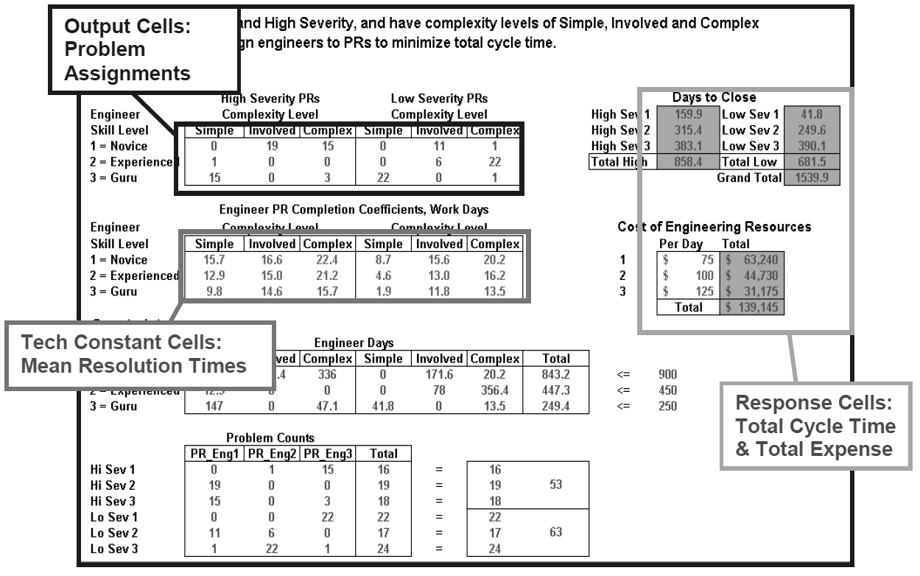
Fig. 1. Output from the Cycle Resolution Time Optimization Algorithm
The main effects plot and the intersection plot are useful tools for visualizing and analyzing the effects for factors. In this paper, we only use the main effects plot because we conclude from MINITAB 16 Taguchi experiment results, because factors interactions are not significant at 95% confidence level. The main effects plots for outputs: Resolution time and Cost are shown in Fig. 3.
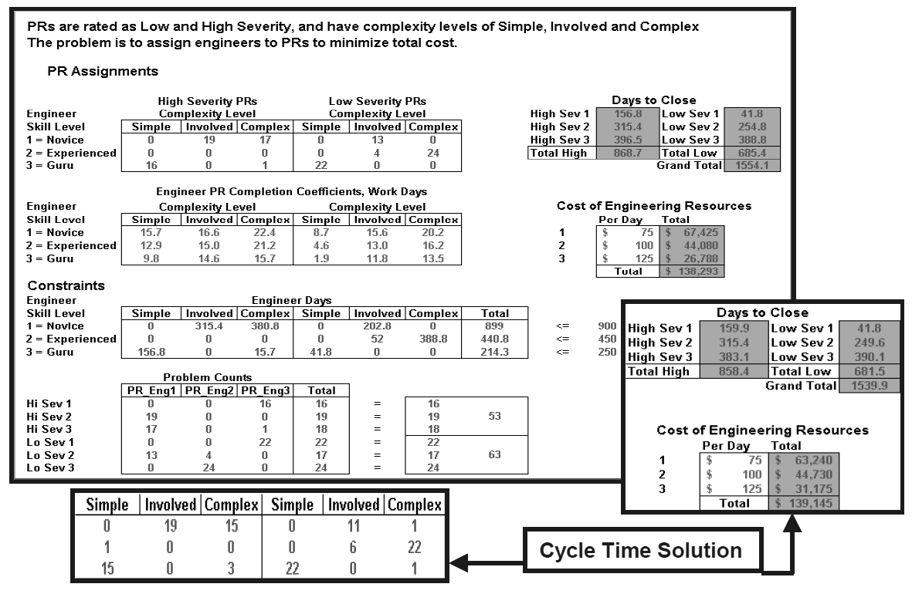
Fig. 2. Output from the Cost Optimization Algorithm

High slope of line means that the factor gives more impact on the experimental results than other factors. Referring to the Ranking table of Taguchi analysis for Cost to fix [$] and Total Resolution time [Days] versus controlled factors Severity, Complexity and engineers Experience, the slope and graphs on figure 3, we observe that the most influential factor is the Complexity factor, then Severity, and Experience factor in our experiments for Cost to fix output. Also, we observe that the most influential factor for Total Resolution time output, again is the Complexity factor, then Experience, and Severity factor in our experiments. Taguchi optimization for cost to fix design explain author’s [1] surprise that “The optimal solution is interesting because, contrary to expectations, the gurus are mostly assigned to low complexity problems, with some preference for low severity.”. According to Taguchi method for PR allocation we developed ranking procedure:
Step 1 - Assign PR of Simple complexity and Low severity (most influential factors first) to the Guru engineers, then
Step 2 - Simple complexity and High severity PR assign, again to Guru if there exists available time (days), then
Step 3 - Average complexity and Low severity PR, again assign to Guru if there exists available time (days) and to Experienced skill engineers, OR if there does not Guru available time (days) exists, then assign PR to Experienced skill engineers, then
Step 4 - Average complexity and High severity PR assign, again to Experienced skill engineers if there exists available time (days) and to Novice skill engineers, OR if there does not exists Experienced skill engineers available time (days), then assign PR to Novice skill engineers, and
Step 5 – Complex and Low, then Complex and High severity PR assign to the Novice until available time (days) exists.
Similar ranking procedure should be applied to optimize Total Resolution time taking into account that the most influential factor for Total Resolution time output, again is the Complexity factor, then Experience, and Severity factor in our experiments. Taghuchi approach optimization PR assignment tables for Total Resolution time and Cost to fix output are presented on Tables 2 and 3.

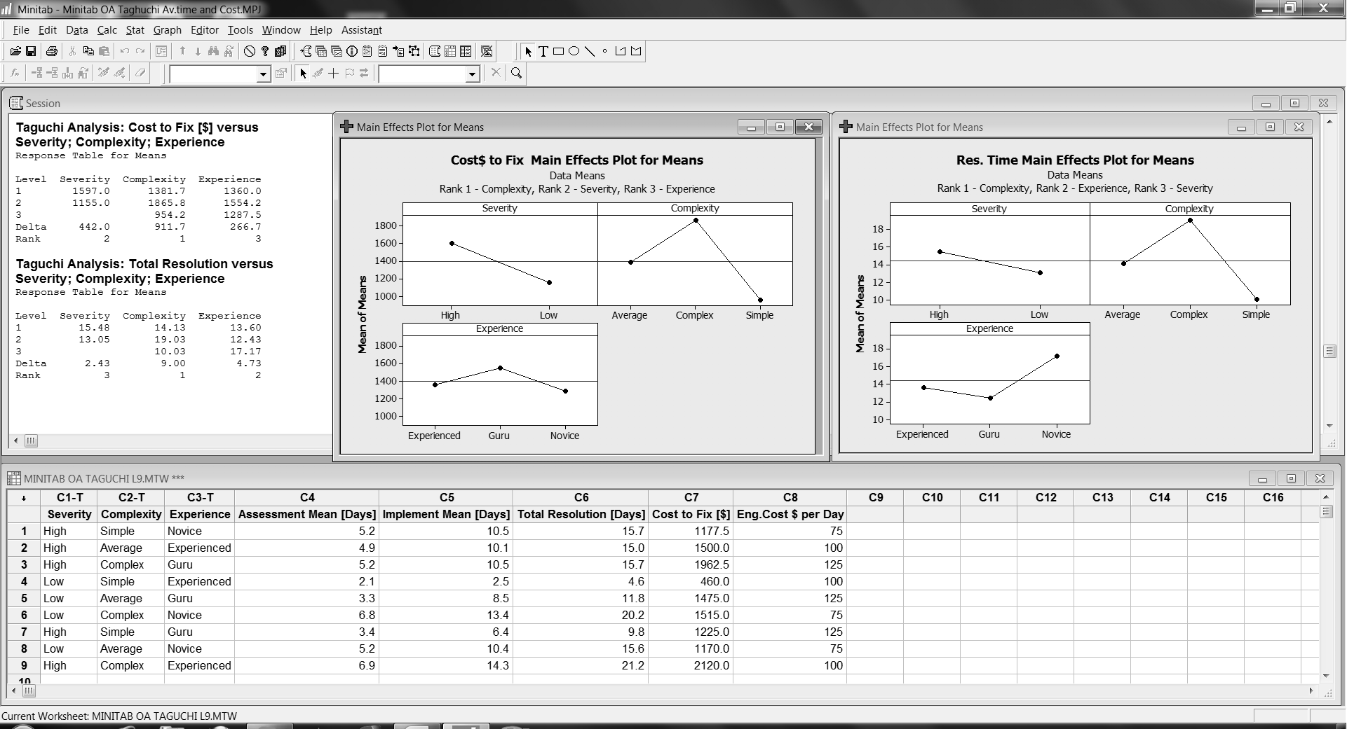
Fig. 3 Output from the Time resolution and Cost Optimization using Taguchi method

Advantages of our Taguchi method application to minimize Total Resolution time output is that Grand Total = $142770 is higher only 3.2% compared to author’s [1] linear programming approach, but in Taguchi case staff resource reserve is 7.8 days instead 45 days in author’s [1] case. This means that Taguchi approach can be used for more accurate staff effort maintenance planning and, of course, for PR assignment effort for maintenance task of delivered software product. Also, advantage of our Taguchi method application to minimize Cost to fix output is that Grand Total = $141853 is higher only 2.6% compared to author’s [1] linear programming approach, but in Taguchi case staff resource reserve is 21 days instead 45 days in author’s [1] case. Again, Taguchi approach can be used for more accurate staff effort maintenance planning and, of course, for PR assignment effort for maintenance task of delivered software product, allowing project managers to see the consequences of choosing cost over schedule or vice-versa.

Table 2. Taguchi Problem Counts for Time resolution Table 3. Taguchi Problem Counts for Cost to Fix
PR_Eng1 | PR_Eng2 | PR_Eng3 | Severity and Complexity |  | PR_Eng1 | PR_Eng2 | PR_Eng3 | Severity and Complexity
0 | 16 | 0 | Hi Sev 1 |  | 0 | 0 | 22 | Hi Sev 1
19 | 0 | 0 | Hi Sev 2 |  | 0 | 0 | 16 | Hi Sev 2
18 | 0 | 0 | Hi Sev 3 |  | 0 | 17 | 0 | Hi Sev 3
0 | 0 | 22 | Lo Sev 1 |  | 4 | 15 | 0 | Lo Sev 1
0 | 0 | 17 | Lo Sev 2 |  | 24 | 0 | 0 | Lo Sev 2
9 | 15 | 0 | Lo Sev 3 |  | 15 | 0 | 3 | Lo Sev 3
Grand Total = $142770, %Delta= 3.2%, Reserve 7.8 instead 45 Days |  |  |  |  | Grand Total = $141853, %Delta= 2.6%, Reserve 21 instead 45 Days

Acknowledgement

This work has been done within the project ‘Optimal Software Quality Management Framework’, supported in part by the Ministry of Science and Technological Development of the Republic of Serbia under Project No.TR-35026.

Conclusions

Software development activities, in every phase, are error prone so defects play a crucial role in software development. In this case study, a quick deterministic Taguchi Design of Experiment method is described to prioritize problems and implement their solution that helps to reduce maintenance cycle time and costs.
This paper describes such an implemented solution, a Taguchi approach which can be used for more accurate staff effort maintenance planning and, of course, for problem reports assignment effort for maintenance task of delivered software product, allowing project managers to see the consequences of choosing cost over schedule or vice-versa.

References

[1] Porter D. Problem Resolution Optimization, Senior Statistician, Motorola, on web site www.stickyminds.com, visited 2013.
[2] Gopalakrishnan Nair, T R. Suma V., Nithya G. N. Estimation of the Characteristics of a Software Team for Implementing. Software Quality Professional; Mar 2011; 13, 2; ProQuest Central, pg. 14
[3] Lj. Lazić, I. Đokić, S. Milinković, „Estimating Cost and Defect Removal Effectiveness in SDLC Testing activities“, INFOTEH-JAHORINA 2013, Jahorina, Proceedings Vol. 12,, ISBN 978-99955-763-1-8, March 2013. pp.572-577.
[4] Jones, Capers, Applied Software Measurement, Global Analysis of Productivity and Quality,
Third Edition, New York: McGraw Hill, 2008.
[5] Lj. Lazić S. Milinković, S. Ilić " OptimalSQM: Optimal Software Quality Management Repository is a Software Testing Center of Excellence", Proc. of 6th WSEAS European Computing Conference (ECC '12), Prague, Czech Republic, September 24-26, 2012, pp. 197- 209.

